A Splendid Little War
By Roger Hudson
Published in History Today Volume 64 Issue 6 June 2014
Roger Hudson sheds light on an 1898 image of US soldiers fighting alongside Cubans to end Spanish rule on the Caribbean island.
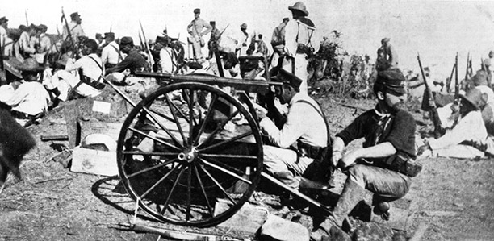
It is June 12th, 1898 and the US Marines have recently landed at Guantanamo Bay, at the eastern end of Cuba. They wear garrison caps while the Cuban mambises(insurgents) have straw hats, though some have been issued with US sailors’ uniforms. War broke out between the Spanish rulers of Cuba and the US on April 24th, but an uprising against colonial rule had started in 1895. Now Americans and Cubans fight alongside each other. The fire power of the wheeled Colt machine gun will be useful, for many US troops are still armed with old-fashioned single-shot, black powder rifles against the Spaniards’ Mausers. Soon the decisive battle of the war will take place nearby, at Santiago, when Theodore Roosevelt will lead his volunteer Rough Riders in a charge (on foot) up Kettle Hill and the Spanish will be defeated. In 1901 Cuba will get her independence, though the US retains the right to intervene, if it is felt that stability there is threatened, and to maintain a permanent naval base at Guantanamo. The Marines will return in 1906, 1913, 1917 and 1933.
Roosevelt was prominent in what was called the ‘expansionist lobby’, those keen to build up the US navy and to join the European states in the projection of their power. Social Darwinism was abroad and he felt that: ‘We must play a great part in the world and especially perform those deeds of blood and valour which above everything else bring national renown.’ The American Frontier, the Wild West, had been declared over and done with in 1893 and so the country had to look outwards for a new challenge. Roosevelt’s friend, Rudyard Kipling, was urging Americans this very year to take up ‘The White Man’s Burden’. Roosevelt, initially, was not fussy over where the US might deploy forces, just so long as there was what he called ‘a splendid little war’ somewhere. In 1895 he had been ready to fight Britain for Canada, using as an excuse a border dispute between British Guiana and Venezuela. But then the victory of Japan over China in 1895, the German establishment of a naval base in China at Tsingtao in 1897 and the Russian presence in Manchuria made the US reconsider its position in the Pacific. In 1898 Congress passed the resolution for a joint annexation of Hawaii and in February that year the US battleship Maine mysteriously blew up in Havana harbour. Roosevelt, then Assistant Secretary of the Navy, was already ambitious for a canal at Panama to link the Atlantic to the Pacific. It would be convenient if any threat of Spanish interference at its Caribbean end were removed and the Maine provided an excuse to lever them out of Cuba. While the US was at it, the Spanish colony of the Philippines could also be seized on the far side of the Pacific. Commodore Dewey, a fellow expansionist, was told to take the US Pacific fleet to Hong Kong, with orders to keep its steam up, ready to spring an attack on Manila when war was declared. The plan worked like clockwork and in due course the whole of the Philippines became a US colony together with Guam Island out in the Pacific south of Japan. The US had planted itself firmly on the world stage and Roosevelt was on his way to the White House.
- See more at: http://www.historytoday.com/roger-hudson/splendid-little-war#sthash.VlxdEgTT.dpuf
1. What were American motivations behind the Spanish-American War?
2. Why were the Philippines specifically drawn into this American vision?

