Afghanistan profile – Timeline

- 8 March 2017

http://www.bbc.com/news/world-south-asia-12024253
These are external links and will open in a new window
A chronology of key events:
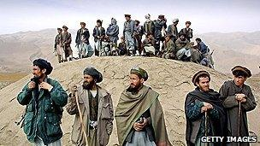Image copyrightGETTY IMAGESImage captionMilitia wait for US planes to bomb Taliban positions in October 2001
1838-42 - British forces invade, install King Shah Shujah. He is assassinated in 1842. British and Indian troops are massacred during retreat from Kabul.
1878-80 - Second Anglo-Afghan War. A treaty gives Britain control of Afghan foreign affairs.
1919 - Emir Amanullah Khan declares independence from British influence.
1926-29 - Amanullah tries to introduce social reforms, which however stir civil unrest. He flees.
1933 - Zahir Shah becomes king and Afghanistan remains a monarchy for next four decades.
1953 - General Mohammed Daud becomes prime minister. Turns to Soviet Union for economic and military assistance. Introduces social reforms, such as abolition of purdah (practice of secluding women from public view).
1963 - Mohammed Daud forced to resign as prime minister.
1964 - Constitutional monarchy introduced - but leads to political polarisation and power struggles.
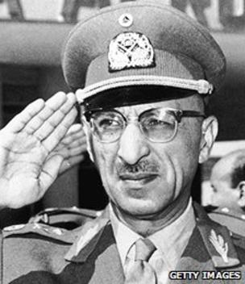Image copyrightGETTY IMAGESImage captionKing Zahir Shah, who ruled for 40 years until he was ousted in 1973
1973 - Mohammed Daud seizes power in a coup and declares a republic. Tries to play off USSR against Western powers.
1978 - General Daud is overthrown and killed in a pro-Soviet coup. The People's Democratic Party comes to power but is paralysed by violent infighting and faces opposition by US-backed mujahideen groups.

Soviet intervention
1979 December - Soviet Army invades and props up communist government.
1980 - Babrak Karmal installed as ruler, backed by Soviet troops. But opposition intensifies with various mujahideen groups fighting Soviet forces. US, Pakistan, China, Iran and Saudi Arabia supply money and arms to the mujahideen.
1985 - Mujahideen come together in Pakistan to form alliance against Soviet forces. Half of Afghan population now estimated to be displaced by war, with many fleeing to neighbouring Iran or Pakistan.
1986 - US begins supplying mujahideen with Stinger missiles, enabling them to shoot down Soviet helicopter gunships. Babrak Karmal replaced by Najibullah as head of Soviet-backed regime.
1988 - Afghanistan, USSR, the US and Pakistan sign peace accords and Soviet Union begins pulling out troops.

Red Army quits
1989 - Last Soviet troops leave, but civil war continues as mujahideen push to overthrow Najibullah.
1992 - Najibullah's government toppled, but a devastating civil war follows.
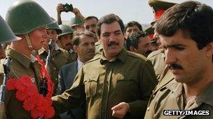Image copyrightGETTY IMAGESImage captionPresident Najibullah (centre) headed the Soviet-backed regime
1996 - Taliban seize control of Kabul and introduce hard-line version of Islam, banning women from work, and introducing Islamic punishments, which include stoning to death and amputations.
1997 - Taliban recognised as legitimate rulers by Pakistan and Saudi Arabia. They now control about two-thirds of country.
1998 - US launches missile strikes at suspected bases of militant Osama bin Laden, accused of bombing US embassies in Africa.
1999 - UN imposes an air embargo and financial sanctions to force Afghanistan to hand over Osama bin Laden for trial.
2001 September - Ahmad Shah Masood, leader of the main opposition to the Taliban - the Northern Alliance - is assassinated.

US-led invasion
2001 October - US-led bombing of Afghanistan begins following the September 11 attacks on the United States. Anti-Taliban Northern Alliance forces enter Kabul shortly afterwards.
2001 December - Afghan groups agree deal in Bonn, Germany for interim government.
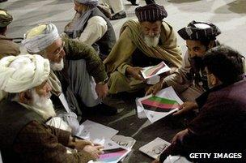Image copyrightGETTY IMAGESImage captionLoya Jirga delegates adopted a new constitution in 2004
Hamid Karzai is sworn in as head of an interim power-sharing government.
2002 January - Deployment of first contingent of foreign peacekeepers - the Nato-led International Security Assistance Force (ISAF) - marking the start of a protracted fight against the Taliban.
2002 April - Former king Zahir Shah returns, but makes no claim to the throne and dies in 2007.
2002 June - Loya Jirga, or grand council, elects Hamid Karzai as interim head of state. Karzai picks members of his administration which is to serve until 2004.
2003 August - Nato takes control of security in Kabul, its first-ever operational commitment outside Europe.

Elections
2004 January - Loya Jirga adopts new constitution which provides for strong presidency.
2004 October-November - Presidential elections. Hamid Karzai is declared winner.
2005 September - Afghans vote in first parliamentary elections in more than 30 years.
2005 December - Parliament opens with warlords and strongmen in most of the seats.
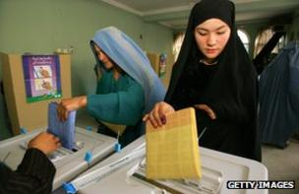Image copyrightGETTY IMAGESImage caption2005 vote: The first parliamentary poll in more than 30 years
2006 October - Nato assumes responsibility for security across the whole of Afghanistan, taking command in the east from a US-led coalition force.
2007 August - Opium production has soared to a record high, the UN reports.
2008 June - President Karzai warns that Afghanistan will send troops into Pakistan to fight militants if Islamabad fails to take action against them.
2008 July - Suicide bomb attack on Indian embassy in Kabul kills more than 50.
2008 September - US President George Bush sends an extra 4,500 US troops to Afghanistan, in a move he described as a "quiet surge".
2009 January - US Defence Secretary Robert Gates tells Congress that Afghanistan is new US administration's "greatest test".
2009 February - Nato countries pledge to increase military and other commitments in Afghanistan after US announces dispatch of 17,000 extra troops.

