Afghanistan 1979 to 2002
http://school.ebonline.com/levels/high/article/Afghanistan-War/488369

Introduction

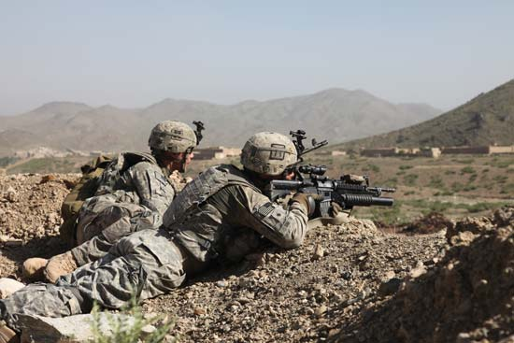
Sgt. Derec Pierson/U.S. Department of DefenseSgt. Derec Pierson/U.S. Department of Defense
Afghanistan War, international conflict in Afghanistan beginning in 2001 that was triggered by the September 11 attacks and consisted of three phases. The first phase—toppling the Taliban (the ultraconservative political and religious faction that ruled Afghanistan and provided sanctuary for al-Qaeda, perpetrators of the September 11 attacks)—was brief, lasting just two months. The second phase, from 2002 until 2008, was marked by a U.S. strategy of defeating the Taliban militarily and rebuilding core institutions of the Afghan state. The third phase, a turn to classic counterinsurgency doctrine, began in 2008 and accelerated with U.S. Pres. Barack Obama’s 2009 decision to temporarily increase the U.S. troop presence in Afghanistan. The larger force was used to implement a strategy of protecting the population from Taliban attacks and supporting efforts to reintegrate insurgents into Afghan society. The strategy came coupled with a timetable for the withdrawal of the foreign forces from Afghanistan; beginning in 2011, security responsibilities would be gradually handed over to the Afghan military and police. The new approach largely failed to achieve its aims. Insurgent attacks and civilian casualties remained stubbornly high, while many of the Afghan military and police units taking over security duties appeared to be ill-prepared to hold off the Taliban. By the time the U.S. and NATO combat mission formally ended in December 2014, the 13-year Afghanistan War had become the longest war ever fought by the United States.

Prelude to the September 11 attacks

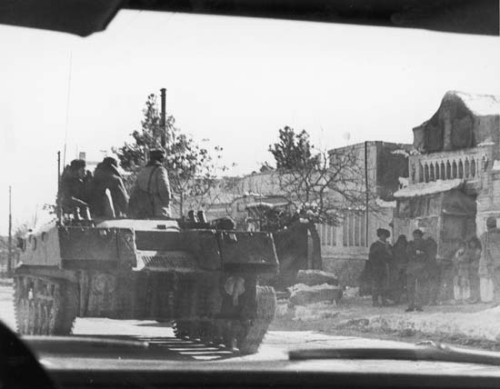
Archive Photos/Getty ImagesArchive Photos/Getty Images
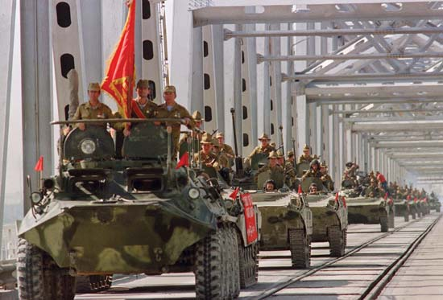
Vitaly Armand—AFP/Getty ImagesVitaly Armand—AFP/Getty Images

The joint U.S. and British invasion of Afghanistan in late 2001 was preceded by over two decades of war in Afghanistan. On December 24, 1979, Soviet tanks rumbled across the Amu Darya River and into Afghanistan, ostensibly to restore stability following a coup that brought to power a pair of Marxist-Leninist political groups—the People’s (Khalq) Party and the Banner (Parcham) Party. But the Soviet presence touched off a nationwide rebellion by Islamist fighters, who won extensive covert backing from Pakistan, Saudi Arabia, and the United States and who were joined in their fight by foreign volunteers. The guerrilla war against the Soviet forces led to their departure a decade later (see Afghan War). In the void, civil war reigned, with the Islamist fighters—known as the mujahideen—battling first to oust the Soviet-backed government and then turning their guns on each other.

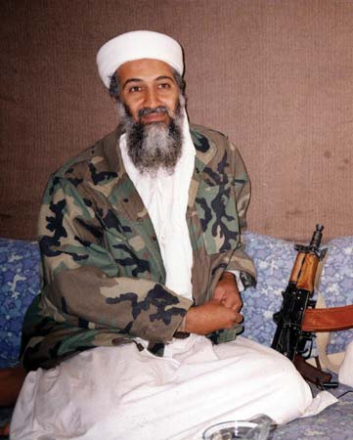
AUSAF/AFP/Getty ImagesAUSAF/AFP/Getty Images

In 1996 the Taliban seized Kabul and instituted a severe interpretation of Islamic law that, for example, forbade female education and prescribed the severing of hands, or even execution, as punishment for petty crimes. That same year, al-Qaeda leader Osama bin Laden was welcomed to Afghanistan (having been expelled from Sudan) and established his organization’s headquarters there. With al-Qaeda’s help, the Taliban won control of over 90 percent of Afghan territory by the summer of 2001. On September 9 of that year, al-Qaeda hit men carried out the assassination of famed mujahideen leader Ahmad Shah Masoud, who at the time was leading the Northern Alliance (a loose coalition of mujahideen militias that maintained control of a small section of northern Afghanistan) as it battled the Taliban and who had unsuccessfully sought greater U.S. backing for his efforts.

The September 11 attacks and the U.S.-British invasion

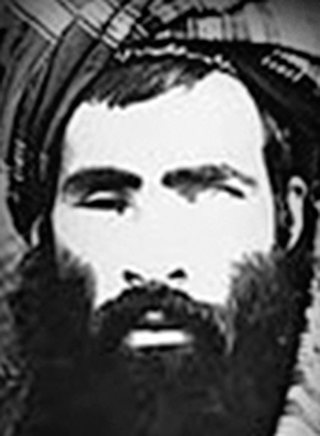
NATIONAL COUNTERTERRORISM CENTER/Reuters /LandovNATIONAL COUNTERTERRORISM CENTER/Reuters /Landov

The hijacking and crashing of four U.S. jetliners on September 11, 2001, brought instant attention to Afghanistan. The plot had been hatched by al-Qaeda, and some of the 19 hijackers had trained in Afghanistan. In the aftermath of the attacks, the administration of U.S. Pres. George W. Bush coalesced around a strategy of first ousting the Taliban from Afghanistan and dismantling al-Qaeda, though others contemplated actions in Iraq, including long-standing plans for toppling Pres. Saddam Hussein. Bush demanded that Taliban leader Mullah Mohammed Omar “deliver to [the] United States authorities all the leaders of al-Qaeda who hide in your land,” and when Omar refused, U.S. officials began implementing a plan for war.

