BATTLE OF MANILA BAY

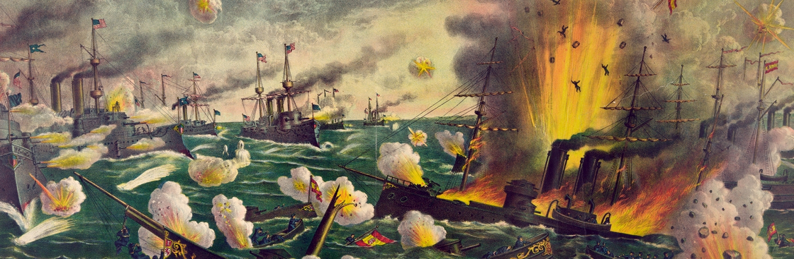
http://www.history.com/topics/battle-of-manila-bay
On May 1, 1898, at Manila Bay in the Philippines, the U.S. Asiatic Squadron destroyed the Spanish Pacific fleet in the first major battle of the Spanish-American War (April-August 1898). The United States went on to win the war, which ended Spanish colonial rule in the Americas and resulted in U.S. acquisition of territories in the western Pacific and Latin America.

SPANISH-AMERICAN WAR: BACKGROUND
The Spanish-American War had its origins in the rebellion against Spanish rule that began in Cuba in 1895. The repressive measures that Spain took to suppress the guerrilla war, such as herding Cuba’s rural population into disease-ridden garrison towns, were graphically portrayed in American newspapers and inflamed public opinion.

Did You Know?
In 1903, George Dewey became the only U.S. naval officer ever promoted to the rank of admiral of the Navy.
In January 1898, violence in Havana led U.S. authorities to order the battleship USS Maine to the city’s port to protect American citizens. On February 15, a massive explosion of unknown origin sank the Maine in the Havana harbor, killing 260 of the approximately 400 American crewmembers aboard. An official U.S. Naval Court of Inquiry ruled in March, without much evidence, that the ship was blown up by a mine, but did not directly place the blame on Spain. However, much of Congress and a majority of the American public expressed little doubt that Spain was responsible and called for a declaration of war.
In April, the U.S. Congress prepared for war, adopting joint congressional resolutions demanding a Spanish withdrawal from Cuba and authorizing President William McKinley (1843-1901) to use force. On April 23, McKinley asked for 125,000 volunteers to fight against Spain. The next day, Spain issued a declaration of war. The United States declared war on April 25.
U.S. Commodore George Dewey (1837-1917), in command of the U.S. Asiatic Squadron anchored north of Hong Kong, was ordered to capture or destroy the Spanish Pacific fleet, which was known to be in the coastal waters of the Spanish-controlled Philippines.

BATTLE OF MANILA BAY: MAY 1, 1898
On April 30, Dewey’s lookouts caught sight of Luzon, the main Philippine island. That night, under cover of darkness and with the lights aboard the U.S. warships extinguished, the squadron slipped by the defensive guns of Corregidor Island and into Manila Bay.
After dawn, the Americans located the Spanish fleet, a group of out-of-date warships anchored off the Cavite naval station. The U.S. fleet, in comparison, was well-armed and well-staffed, largely due to the efforts of the energetic assistant secretary of the Navy, Theodore Roosevelt (1858-1919), who had also selected Dewey for the command of the Asiatic squadron.
At around 5:40 a.m., Dewey turned to the captain of his flagship, the Olympia, and said, “You may fire when ready, Gridley.” Two hours later, the Spanish fleet was decimated, and Dewey ordered a pause in the fighting. He met with his captains and ordered the crews a second breakfast. The surviving Spanish vessels, trapped in the little harbor at Cavite, refused to surrender, and late that morning fighting resumed. Early that afternoon, a signal was sent from the gunboat USS Petrel to Dewey’s flagship announcing that the enemy has surrendered.
Spanish losses were estimated at more than 370 troops, while American casualties were fewer than 10.

BATTLE OF MANILA BAY: AFTERMATH
Dewey’s decisive victory cleared the way for the U.S. occupation of Manila in August and the eventual transfer of the Philippines from Spanish to American control. In Cuba, Spanish forces likewise crumbled in the face of superior U.S. forces, and on August 12 an armistice was signed between Spain and the United States.
In December, the Treaty of Paris officially ended the brief Spanish-American War. The once-proud Spanish empire was virtually dissolved, and the United States gained its first overseas empire. Puerto Rico and Guam were ceded to America, the Philippines were bought for $20 million, and Cuba became a U.S. protectorate. Philippine insurgents who fought against Spanish rule during the war immediately turned their guns against the new occupiers, and a significantly greater number of American troops died suppressing the Philippines than in defeating Spain.

