Cambodian Stimulus 1:
https://pisaspeak.wordpress.com/?s=

Search...

PISASPEAK

Legacies of the Cold War in Asia: Cambodia
27OCT
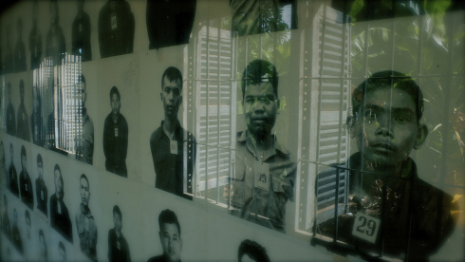
By PISA Staff Assistant, Leeann Ji
To understand the workings of a nation, one must observe the trials and tribulations it has undergone throughout its history. In the case of the Kingdom of Cambodia, its vibrant national history is scarred by the consequences of the Cold War, the Vietnam War, and the Cambodian Genocide. At PISA, we believe in studying these subjects in order to develop strategies that seek to prevent these conflicts from arising again.
Beginning in 1969, the U.S. secretly carpet bombed Cambodia as it had done in Laos following King Sihanouk’s decision to allow the Communist People’s Army of Vietnam (PAVN) into Eastern Cambodia to use the Sihanouk Trail, a trail-turned-supply route on the border between Cambodia and Vietnam. Over the course of 4 years, the U.S. dropped about 540,000 tons of bombs killing up to 500,000 Cambodians in what became known as “Operation Breakfast.” Though Sihanouk attempted to reestablish diplomatic relations with the U.S. to end the bombing campaign, the U.S. deemed Sihanouk untrustworthy due to his ties to the People’s Republic of China (PRC), North Vietnam, and the Soviet Union — all communist adversaries of the U.S. during the Cold War. In 1970, Sihanouk was overthrown by the pro-American Lon Nol, who saw the spillover of the Vietnam War across its borders. The communist Khmer Rouge movement led by Pol Pot gained momentum with the help of North Vietnam, the PRC, and Sihanouk. This led to an increase in the group’s popularity, which paved the way for the Khmer Rouge’s route to power in April 1975.

Pol Pot admired the Chinese model of communism and sought to create a communist, agrarian utopia in Cambodia. He forced citizens to leave their homes in the city and put them in labor camps where they suffered from starvation and abuse. Intellectuals, doctors, teachers, and some members of the Cambodian army were seen as threats to Cambodian communism, and thus Pol Pot had many of them executed. Between 1975 and 1979 when the Vietnamese overthrew Pol Pot, it is estimated that between 1.7 and 2 million Cambodians perished in the genocide.

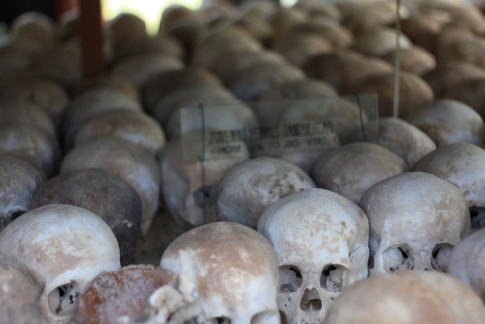
In addition to the Unexploded Ordinance (UXO) from Operation Breakfast, the Vietnamese left landmines during the ousting of the Khmer Rouge in 1979. To this day, about 50 percent of Cambodian minefields have been cleared, but this came at a price of 64,000 casualties and 25,000 amputees since 1979. The Cambodian Genocide, too, has left a lasting impression on Cambodian society where many families have yet to be reunited with lost relatives or even determine the fates of their missing loved ones. Under Pol Pot, Cambodia saw the slaughter of its citizens and a massive setback in national development. As a result, the country now lags behind its Southeast Asian neighbors in almost every aspect of development: 10.1% of Cambodians live on less than $1.25 a day; about 42% of the Cambodian population has no access to clean drinking water; and 32% of Cambodian children experienced stunted growth before age 5.

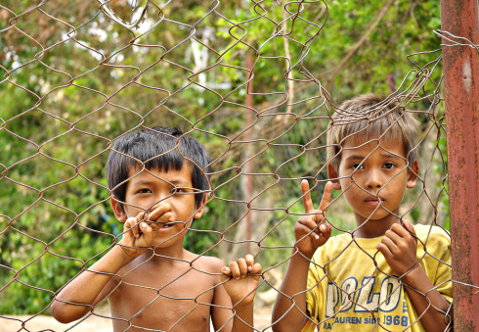
Despite these major setbacks, Cambodia has worked tirelessly to prevent the reemergence of the Khmer Rouge. In 2006, with the help of the United Nations, Cambodia established the Extraordinary Chambers in the Courts of Cambodia (ECCC) to bring war criminals associated with the Genocide to stand trial for their human rights violations. Since its establishment, the ECCC has pursued 4 active cases, which are available to the public in order to make transparent the judicial process. The Cambodian Genocide exists as perhaps the most lasting legacy of the Cold War on Cambodia, and as the nation begins to rebuild and develop, it does not forget the lives lost and the lessons learned.
Advertisements

