http://www.aljazeera.com/indepth/features/2016/11/161129085116132.html

Fidel Castro: A Latin American story
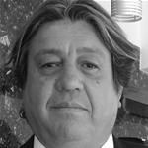by Javier Farje
29 Nov 2016
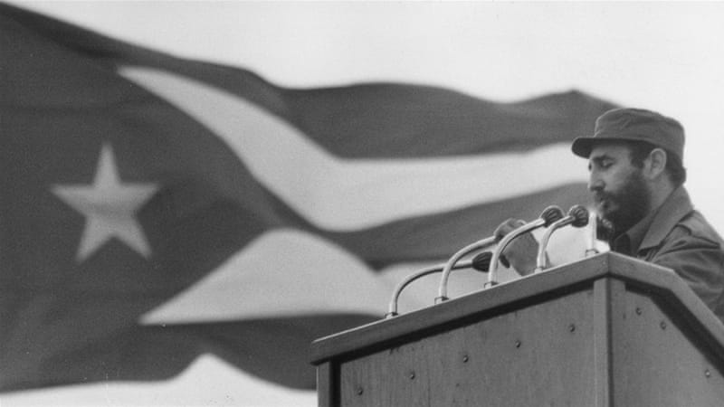
Fidel Castro giving a speech with the national flag of Cuba in the background [Keystone/Getty Images]

When Fidel Castro and his barbudos (the bearded ones) entered Havana on January 2, 1959, having defeated the dictatorship of Fulgencio Batista, Latin America was in turmoil.
In the Andean region of South America, a feudal system of land ownership prevailed. Indigenous people worked for very low wages and owed lifelong loyalty to their masters. In Central America, the United Fruit Company (UFC), an American multinational, owned much of the land and railroads.
Any attempts to address such inequalities were crushed in their infancy. In 1954, President Jacobo Arbenz of Guatemala tried to implement a land reform. A coup d'etat promoted by the UFC and Washington put an end to Arbenz's reformist programme.
The United States also actively supported dictatorial regimes in Paraguay, Guatemala, Nicaragua, the Dominican Republic and Haiti.
By the end of the 1950s, according to the Latin American and Caribbean Demographic Centre, life expectancy in the region was 47 years.
Fidel Castro was aware of the impact that his movement had in Latin America. In one of his first addresses to the Cuban people after his victory in 1959, Castro said: "Compañeros, the revolution is not our exclusive property, nor is it only here on the island. Our brothers in Latin America cannot fail to join us."
It was a call to arms that many middle-class intellectuals and activists took seriously.
In the mid-1960s, Latin America saw the emergence of guerrilla groups, many of whose members were trained in Cuba. In Nicaragua, Peru, Bolivia, Argentina, Venezuela and Ecuador, units of badly armed guerrillas tried to repeat the Cuban experience, mainly in the countryside.
They were mercilessly crushed by national armies, many of whose officers had been educated in the dubious art of counter-insurgency by the US at the School of the Americas in Panama.
By 1967, when Che Guevara was executed in Bolivia after he failed in his efforts to form a guerrilla group to invade his native Argentina, armed struggle as an instrument of change had fizzled out.
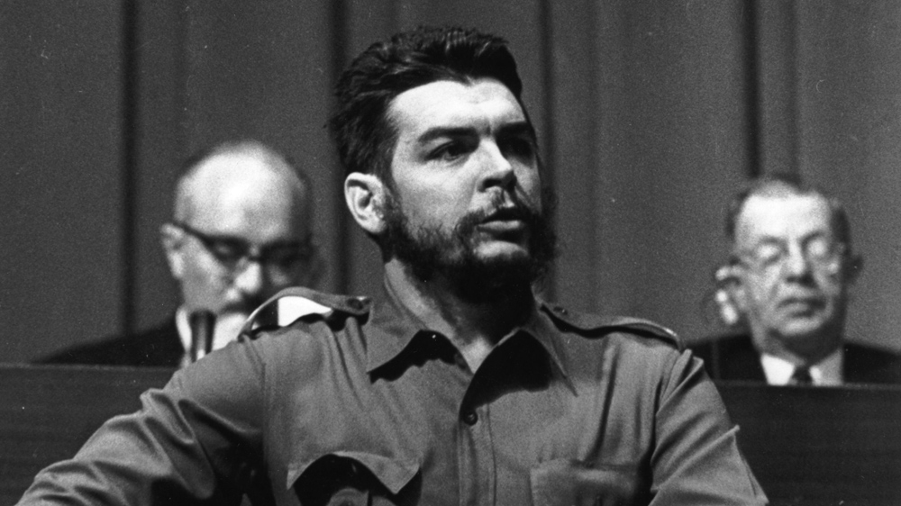
Argentine Communist revolutionary leader Ernesto Che Guevara speaking at the World Commerce and Development Conference at the Palace des Nations at Geneva [Keystone/Getty Images]
However, some governments in the region understood that the guerrillas were not a bunch of cattle rustlers; in fact, those rebels reflected a genuine anger at the levels of injustice that existed in their societies. In 1968, Peru's military government led by General Juan Velasco implemented a land reform. "If we don't carry out this reform, the Castroists will, and we don't want that, do we?" quipped a minister in 1969. Ironically, Velasco re-established diplomatic relations with Castro's Cuba. The General and the Comandante became good friends.
In Panama, General Omar Torrijos also took power in 1968. In 1976, during a visit to Cuba, Torrijos said that Fidel was "a symbol of the efforts for continental unity in the fight for its identity and its final integration ... and a consistent, loyal and dignified friend". Military governments in Ecuador and Bolivia followed the same pattern.
In 1970, a socialist doctor, Salvador Allende, was elected president of Chile. Allende wanted to prove that it was possible to conduct a revolution within a multiparty system. Fidel Castro visited Chile in 1971. He spent three weeks in the South American country.
This was Castro's longest ever state visit. The coup d'état on September 11, 1973, during which Allende died defending democracy, put an end to the pacific uprising that he thought was possible.
In a tribute to Allende in the Plaza de la Revolucion in Havana, on September 28, 1973, in the presence of Allende's widow, Castro expressed, in the kindest possible way, his reservations about the peaceful path to revolutionary changes. "[Allende's victory] did not mean a victory of a revolution," said Castro, "but access to important positions by legal and peaceful means."
After a period of revolutionary stagnation in Latin America, Fidel Castro's influence dwindled; but in 1979, his ideological standpoint got a new boost.
In Nicaragua, the Sandinista National Liberation Front (FSLN) defeated the dictatorship of Anastasio Somoza. Although the Sandinista movement got its main inspiration from Augusto Cesar Sandino, a guerrilla general who fought against the US-sponsored dictatorship of Anastasio's father in the 1930s, many of the FSLN comandantes had trained in Cuba. Unlike Cuba, the FSLN adhered to the concept of multi-party democracy.
The Sandinista leader, Daniel Ortega, won a general election in 1984, at the height of revolutionary fervour. His government implemented a series of reforms modelled on the Cuban system: land redistribution, nationalisation of industries, popular participation.
However, the proxy war executed by then US President Ronald Reagan against the Sandinistas had a demoralising effect on the population. A well-armed gang known as the contras conducted a violent campaign against the government.
The US government openly supported, armed and trained the contras. In the 1990 elections, the FSLN lost power. People just wanted peace and voting the Sandinistas out of power was the best way to achieve that. And Cuba lost an ally.
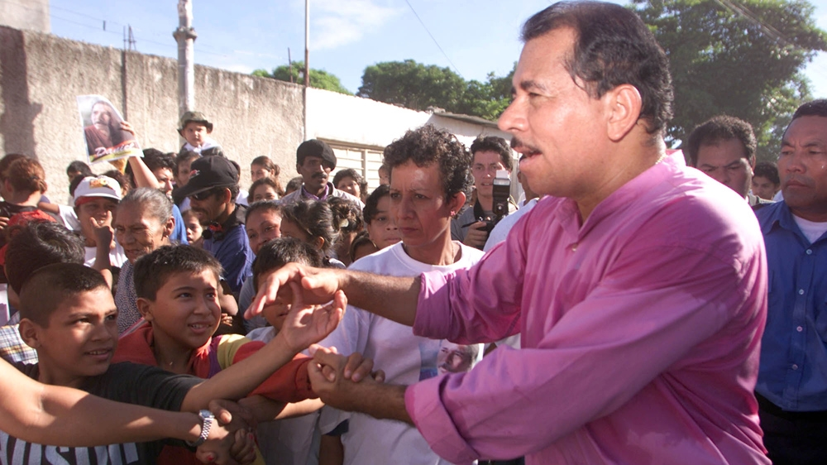
Nicaraguan presidential candidate Daniel Ortega greets supporters on the last day of the campaigning [Max Trujillo/Getty Images]

Hard times
Cuba paid a heavy price for the collapse of the Soviet bloc. The island could no longer rely on the support of Moscow and by the early 1990s, the island experienced hardship and suffering. Many forecast the end of the Cuban Revolution. They were wrong.
But by the mid-1990s, Cuba started to recover. In the rest of the continent, the traditional parties that had dominated the political landscape in Latin America for decades believed that their grip on power could not be challenged. Then, in Venezuela in 1999, Lieutenant-Colonel Hugo Chavez, who had unsuccessfully tried to depose the government of Carlos Andres Perez in 1992, was elected president.
As a young officer, Chavez had two big influences: Simon Bolivar, the liberator of Venezuela during the anti-colonial wars in the 19th century, and Fidel Castro. Afterwards, a succession of left-wing governments was elected: Argentina, Bolivia, Brazil, Ecuador, Honduras, Nicaragua (the return of Daniel Ortega), Uruguay. They all claimed to be inspired by the Cuban Revolution and Fidel Castro's leadership.
The Cuban Revolution has endured and Latin America has learned to live with it. The same can be said about its leader because Fidel Castro personified the revolution, its accomplishments and also its shortcomings.
In 2010, the countries of the region decided to create the Community of Latin American and Caribbean States (CELAC). They excluded the United States and Canada. Cuba was invited to join.
For the first time since 1962, when Cuba was expelled from the Organisations of American States, the island became a member of a regional body.
In January 2014, the island hosted the second CELAC summit. In December of the same year, Washington and Havana announced that they were going to re-establish diplomatic relations. Every single government in the region welcomed the decision. In March 2016, Barack Obama became the first American president to visit Cuba in almost 90 years.
Fidel Castro helped to shape the history of Latin America since the second half of the 20th century. For his followers, he was a father figure who inspired the struggle for change.
For his enemies, he was a communist tyrant. During his trial for the failed attack on the Moncada barracks in 1953, in his final plea before sentencing, Castro ended his speech saying: "Condemn me, it does not matter, history will absolve me." His absolution may be, for some people, debatable. But the history of Latin America will have to include chapters with Fidel Castro's name at the very top of the page.
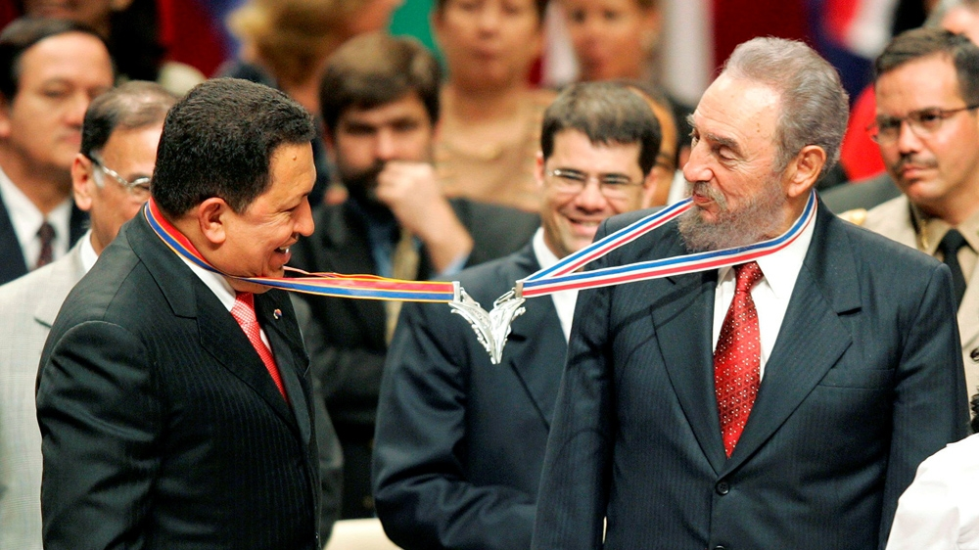
Venezuela's President Hugo Chavez, left, and his Cuban counterpart Fidel Castro joke after joining their medallions, given by medical graduates, at Havana's Karl Marx theatre [Claudia Daut/Reuters]

Javier Farje is a Peruvian-born British journalist based in London. He is an analyst with TV networks from Latin America and the Middle East.

