Dropping like flies: the gerontocracy in the last years of the Soviet Union.
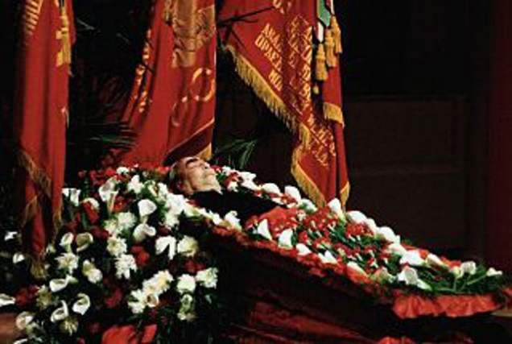
Posted on January 7, 2014 by Sean Munger in History
In May 1982, Leonid I. Brezhnev, General Secretary of the Union of Soviet Socialist Republics, suffered a severe stroke. It was not unexpected. Brezhnev was 75, smoked heavily, drank like a fish and had already (barely) survived bouts with leukemia and cancer of the jaw. He’d been the leader of the USSR and one of the most powerful men in the world since 1964, but by the early ’80s he was pretty checked out, rarely leaving his dacha near Moscow. No one in the upper echelons of the USSR really had the guts or the desire to tell the leader he was no longer competent to run the world’s second superpower, so Brezhnev lingered on, still in office, for a few more months. There was also a political problem: if and when he died, who would the Politburo–a cabal of aging Communist bureaucrats–get to replace him?
The time for that decision came on November 10 of the same year. Brezhnev had a heart attack. A couple of figures high-up in the Politburo had been jockeying for power in the inevitable coming of Brezhnev’s death, and the most ruthless of them was Yuri Andropov, who until May had been head of the KGB. Two days after Brezhnev finally checked out the Politburo voted him into office as his successor.
All well and good, right? Well, not so much. You see, Andropov, at 69, was no spring chicken either, and was only marginally healthier than Brezhnev had been. He’d been on the job for barely three months before he suffered a total kidney failure. On dialysis, Andropov rallied slightly throughout the spring and summer of 1983, but then his health took a turn for the worse in August–just before the shootdown of KAL Flight 007, one of the tensest episodes of the entire Cold War. When Andropov checked into Moscow’s Central Clinical Hospital, he probably knew he was going out feet-first. It was just a matter of time.

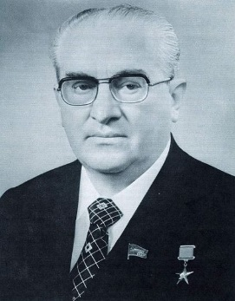
Who wants a leader with chronic kidney failure? Evidently the Soviet Central Committee preferred Andropov to finding a younger man who might have radical ideas about trying to make the USSR suck a little less.
Indeed, by December, after barely more than a year in office, Andropov was totally bedridden. Aides brought him paperwork and briefed him on political and foreign policy matters at the side of his hospital bed. Basically he wasn’t governing at all. He’d suggest ideas to his aides, and they’d go and carry out policy. His aides had a stamp for his signature. In January Andropov got blood poisoning, possibly from all the medications he was taking. On February 9, 1984, he joined Brezhnev at the great Party Congress in the sky.
By now it was obvious to everyone that this system of gerontocracy–rule by old sick men–simply didn’t work. Andropov himself knew that a younger and more energetic man was needed to lead the USSR, especially in this difficult time of international tension and economic stagnation at home. In fact, not long before his death Andropov wrote a handwritten addendum to a document in which he suggested that Mikhail Gorbachev, his aide, succeed him. Under Soviet law this had no legal force but it should have ensured things politically; nonetheless the Politburo bureaucrats, terrified of even the slightest hint of change, simply ignored the directive. The Central Committee instead tapped Konstantin Chernenko, who was older than Andropov. On February 13, 1984, he became the USSR’s third chief in a year and a half.
Third time’s the charm, right? Not quite. Chernenko was already sick when they voted him in. He could barely stand at the podium to read his predecessor’s eulogy. Between his respiratory ailments (including emphysema), occasional heart failure and liver disease from too much vodka, Chernenko was absent from state meetings more often than he was present, often represented by Gorbachev. When he was there he was almost a living corpse. An aide had to prop his hand up for him to vote. By the end of 1984 he was largely bedridden, in the same hospital where Andropov had spent his last few months. You’d hope they changed the sheets.

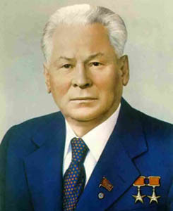
This official portrait of Konstantin Chernenko was created with the 1980s Soviet version of Photoshop: a couple of colored pencils and an airbrush.
By late February 1985 there was no getting around it: Chernenko was dying and the USSR was fresh out of old men with hard-line credentials who could be wheeled up to the platform to pretend to be the Soviet leader. Reluctantly the Politburo and the Central Committee turned to Gorbachev, who had been running a lot of the government by himself anyway as Chernenko’s deputy. Not to be outdone, Chernenko developed one last illness–hepatitis–and died at the hospital on March 10, 1985. Gorbachev was acclaimed the same day. For the better part of three years the USSR had essentially been leaderless, an extended period of bare-bones, sick-room administration, not unlike Edith Wilson’s unusual stewardship of the U.S. Presidency during her husband Woodrow’s long illness.
The hard-liners were right to be worried. Gorbachev did the one thing they feared the most: he instituted reforms, or at least tried to. The campaign of reform Gorbachev launched eventually spun out of his control, and six years later the nation he inherited ceased to exist.
The example of the pathetic “gerontocracy” in the final years of the USSR demonstrates a curious phenomena among countries whose governments come to power as a result of revolution: it’s really hard to transition the nation from the revolutionary generation to the successor generation. Brezhnev, Andropov and Chernenko were all born in Tsarist Russia; although they were kids at the time of the Bolshevik revolution of 1917, they earned their political chops in the early days of the USSR and under its original revolutionary leaders, Lenin and Stalin. Gorbachev, by contrast, was the first (and only) Soviet leader born during the existence of the USSR itself (he was born in 1931). Communist China went through this same process. Every leader was a revolutionary until the death of Deng Xiaoping in 1997, nearly 50 years after the revolution. The handoff to the next generation was very rocky.
Lest you think this dearth of revolutionary “succession planning” missed the United States, it didn’t. Of the first seven Presidents, five were themselves participants in the American Revolution, the sixth (Quincy Adams) was the son of a revolutionary, and the seventh (Andrew Jackson) was a teenager who came of age during the revolution. It wasn’t until 1836 that the first American actually born under the United States of America was elected President.
Gerontocracy is a pretty poor form of government. As U.S. President Ronald Reagan famously remarked when told of the death of Chernenko, “How am I supposed to get anyplace with the Russians if they keep dying on me?

