Foreign Policy poster activity

Look at the following 5 propaganda posters about Chinese Foreign Policy.
Reorganise the explanations so that they are matched with the correct posters.
In the “Conclusions Drawn” box at the bottom, write in your ideas about the preoccupations of the Chinese with regards to forign policy during Mao’s era.

https://chineseposters.net/themes/foreign-imperialists.php
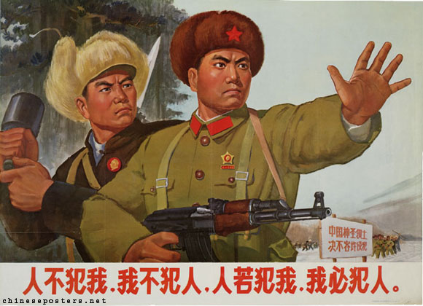 | The fate of aggressors, ca. 1952  After the start of the Korean conflict, the United States officially became China's main foreign adversary. The war provided numerous opportunities to show Americans in an extremely unfavorable light.
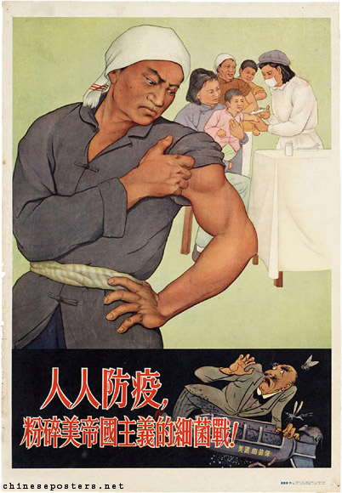 | If people don't attack us, we will not attack them, if they attack us, we will surely attack them, 1970  When the Sino-Soviet split had become unavoidable in the late 1950s, China virtually had no allies left in the international community. It felt threatened in the North by the military forces of the Soviet Union, which were amassed along the shared Northeastern border, and in the South by the growing military presence of the United States in Southeast Asia. Due to an actual territorial border conflict with the Soviets in 1969 over Zhenbao, or Damanski, Island, which later turned out to have been engineered by the Chinese themselves, the most explicit propaganda about China's fighting resolve henceforth was directed against the Soviet Union.
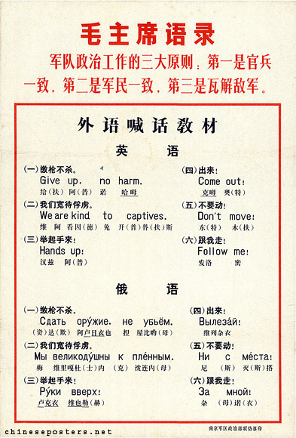 | In the 1960s, protests against the American presence in Vietnam were recurring themes, accompanied by posters that showed the Chinese helping not only the Vietnamese but other Southeast Asian peoples as well.
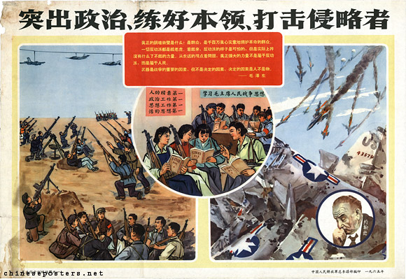 | Everybody must take precautions against epidemics to smash the germ warfare of American imperialism!,  A recurring theme at the time was the accusation that America engaged in bacteriological warfare against China. Starting in 1952, this alledgedly included airdrops of contaminated or disease-carrying rats, insects and other vermin on Chinese soil. As a result, mass inoculation campaigns were organized, in concert with Patriotic Hygiene Campaigns to combat unhygienic conditions in urban and rural areas, and to annihilate potential disease-spreading animals and insects.
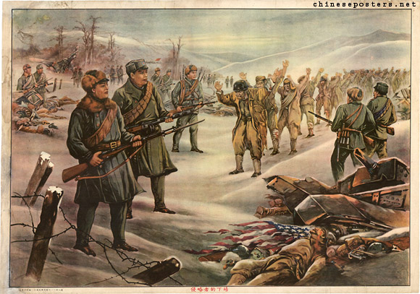 | Propaganda directed to the foreign enemy at the front line teaching materials, early 1970s

Conclusions drawn:

