https://www.theguardian.com/commentisfree/2021/jun/09/case-close-ratko-mladi-war-criminal-genocide-prijedor

The case has closed on Ratko Mladić. Now we must honour those who survived him
Zrinka Bralo
The war criminal was not indicted for genocide over the horrors of Prijedor, but at least he will never be released
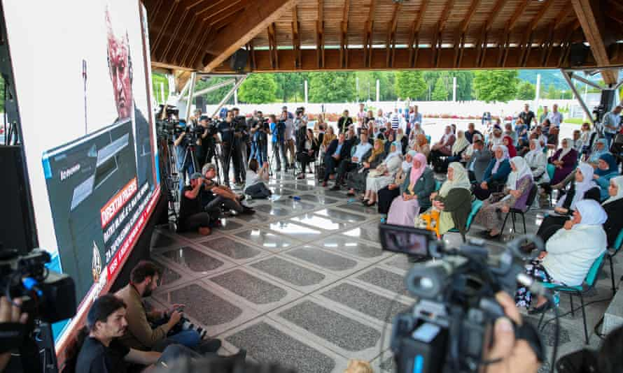
‘Justice may never be fully achieved, especially for those who are still looking for the missing loved ones.’ Bosnian families follow the final verdict hearing of Ratko Mladić at Srebrenica Genocide Memorial, Bosnia and Herzegovina Photograph: Anadolu Agency/Getty Images
Wed 9 Jun 2021 15.00 BST

In June 2011, I watched from London as the war criminal Ratko Mladić, captured after 16 years in hiding, appeared in The Hague. I hastily gathered my thoughts in an article for this publication. As a Bosnian refugee in London, as a Sarajevan whose life was altered by the actions of war criminals like Mladić, I was not jubilant, but perhaps cautiously hopeful that the legal process would give us at least some justice.
Almost exactly 10 years later, this time in Sarajevo, I watched the news as Mladić heard the final verdict on his crimes. In 2017, he was convicted of genocide, war crimes and crimes against humanity, and sentenced to life imprisonment. Both Mladić and the prosecution appealed. The prosecutors did so because they wanted to expand the indictment of genocide to include what happened in six municipalities, including the murder and expulsion of non-Serbs from the Prijedor area in 1992.
Advertisement
I had never been to Prijedor before the war. As a young journalist during the war in Sarajevo, I watched in horror when journalists Ed Vulliamy and Penny Marshall uncovered concentration camps where thousands of people were killed, raped and tortured. Suddenly, the snipers and shelling, as well the starvation, during the siege of Sarajevo did not look that bad in comparison.
As life would have it, when I came to London as a refugee, I ended up working with survivors of camps in Prijedor, more than 2,000 of whom were resettled in the UK in the 1990s. The stories of torture and inhumane treatment that I have heard from them were so violent and traumatic that genocide did not seem to be a strong enough word to describe it.
I went to Prijedor for the first time in 2008. Many of the war criminals had gone back to their old jobs and lives, while Bosnian Muslim and Bosnian Croat survivors were still looking for their loved ones. I was involved with the youth charity Most Mira (Bridge of Peace), founded by Kemal Pervanić, one of the survivors of camps in the Prijedor area.
The visit felt eerie and out of this world. Knowing what I knew about the cruelty and torture, it was hard to meet teachers and talk to them about the logistics of an upcoming youth festival, knowing that they were guards in camps and had blood on their hands. It was hard to look at the beautiful landscape, where every rosebush could be hiding a mass grave. I was humbled by the dignified defiance of the survivors who were slowly coming back, rebuilding their destroyed homes, and still looking for missing people.

I prosecuted Srebrenica war criminals, but I know others are still walking free
Read more

As it turned out, both appeals were refused at The Hague. In a nutshell, the verdict on Tuesday stated that what happened in Prijedor and five other cities was not genocide. But Mladić is going to spend the rest of his life in prison as a war criminal for the genocide he committed in Srebrenica in 1995.
The limitations of the legal process of this kind are hard to square with the reality of our losses and what we have experienced. General Mladić did not spontaneously decide to commit genocide in July 1995, and yet all the other atrocities that took place from 1992 are not included in his sentence. This is especially difficult to process because there is evidence that in May 1992 he calmly clarified in an assembly with his political leadership, also convicted war criminals, that what they were asking him to do constituted genocide.
One way to simplify what happened is to imagine that at the Nuremberg trials, the accused Nazis were convicted for atrocities in concentration camps in Poland, but not in concentration camps in Austria. They would still get the same sentence, but the question is what would be impact on survivors, and what would be political and historical consequences?
From the moment the murder of 8,372 people of Srebrenica in July 1995 was legally declared a genocide, denialism became part of the Serb nationalist narrative. Genocide denial has been described as the final stage of genocide.
So, this verdict marks the end of the process of international justice, but Bosnia and Herzegovina will still be held hostage by continued obstructionism and the rewriting of history: Bosnian Serb leader, Milorad Dodik, responded to yesterday’s verdict by speaking about the “myth” of genocide in Srebrenica.
Justice may never be fully achieved, especially for those who are still looking for the missing loved ones. That is why the current moment should be about honouring survivors, especially those who testified in The Hague, and the dignity with which they respected the verdict.
Looking back on June 2011, some of my modest hopes have been fulfilled. Mladić lived to stand trial and heard more than 100 witnesses. Like Radovan Karadžić, he will spend the rest of his life in prison. In 2018, The Hague Tribunal Archive Centre was opened in Sarajevo’s iconic City Hall Vijećnica, to give electronic access to all case files from the tribunal. Despite the attempts to deny what happened, independent, legal evidence of these crimes will be available for eternity.
- Zrinka Balo is the chief executive of Migrants Organise

