My Lai Source Images
Starter:
What inference can we make from this image about My Lai?
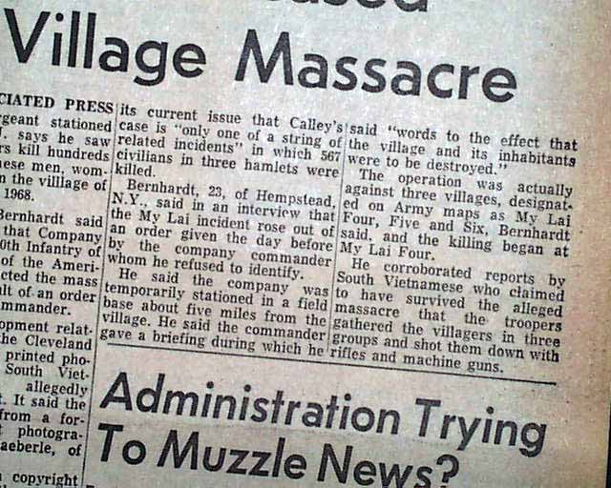

Plenary:
Now you know more about My Lai, explain the message this cartoon magazine cover is trying to convey?

