There are notes below from 3 different sources on American Imperialism in the Philippines

https://library.csun.edu/SCA/Peek-in-the-Stacks/us-imperialism-philippines

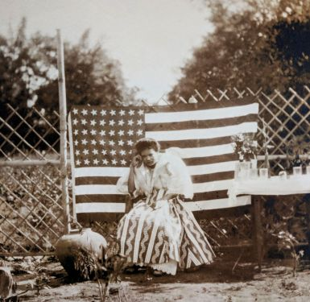Spain established its first permanent settlement in the Philippines in 1565. Spanish colonial control of the Philippines continued until 1898, when the United States took possession of the islands as a territory after winning the Spanish-American War. The Philippine Revolution, a struggle for independence from Spanish colonial rule, had been ongoing since 1896, and news that the US would replace Spain as colonial overlord was unwelcome to many Filipinos. The First Philippine Republic declared independence and established a constitutional government in 1899, which American military officials viewed as an act of insurrection. Later that year, the Philippine-American War broke out as the Republic declared war on the United States. By 1902, when the U.S. Congress passed legislation creating the Philippine Assembly, hundreds of thousands of Filipinos had been killed or died of famine or disease as a result of the brutal war.
While a series of U.S. federal laws gradually increased the amount of legislative authority Filipinos had in their own country, the Philippines was initially administered by an American Governor General and appointed American members of the Philippine Commission as the U.S. military continued to pacify indigenous populations throughout the islands. Though Japan took control of the Philippines during World War II, it returned to U.S. control after the war. In 1946, the U.S. and the Philippines signed the Treaty of Manila, whereupon the United States recognized the independence and sovereignty of the Republic of the Philippines. The Treaty contained a provision that allowed the U.S. to retain existing military bases and assets, which the U.S. continues to actively use.

Spain established its first permanent settlement in the Philippines in 1565. Spanish colonial control of the Philippines continued until 1898, when the United States took possession of the islands as a territory after winning the Spanish-American War. The Philippine Revolution, a struggle for independence from Spanish colonial rule, had been ongoing since 1896, and news that the US would replace Spain as colonial overlord was unwelcome to many Filipinos. The First Philippine Republic declared independence and established a constitutional government in 1899, which American military officials viewed as an act of insurrection. Later that year, the Philippine-American War broke out as the Republic declared war on the United States. By 1902, when the U.S. Congress passed legislation creating the Philippine Assembly, hundreds of thousands of Filipinos had been killed or died of famine or disease as a result of the brutal war.
While a series of U.S. federal laws gradually increased the amount of legislative authority Filipinos had in their own country, the Philippines was initially administered by an American Governor General and appointed American members of the Philippine Commission as the U.S. military continued to pacify indigenous populations throughout the islands. Though Japan took control of the Philippines during World War II, it returned to U.S. control after the war. In 1946, the U.S. and the Philippines signed the Treaty of Manila, whereupon the United States recognized the independence and sovereignty of the Republic of the Philippines. The Treaty contained a provision that allowed the U.S. to retain existing military bases and assets, which the U.S. continues to actively use.

https://courses.lumenlearning.com/boundless-ushistory/chapter/american-imperialism/

The Philippine-American War
The Philippine-American War was an armed conflict that resulted in American colonial rule of the Philippines until 1946.

LEARNING OBJECTIVES
Analyze the Philippine-American War

KEY TAKEAWAYS

Key Points
- The Philippine-American War was part of a series of conflicts in the Philippine struggle for independence, preceded by the Philippine Revolution (1896) and the Spanish-American War.
- The conflict arose from the struggle of the First Philippine Republic to gain independence following annexation by the United States.
- The war and U.S. occupation changed the cultural landscape of the islands. Examples of this include the disestablishment of the Catholic Church as the Philippine state religion and the introduction of the English language as the primary language of government and business.
- The United States officially took control of the Philippines in 1902. In 1916, the United States promised some self-government, a limited form of which was established in 1935. In 1946, following World War II, the United States gave the territory independence through the Treaty of Manila.

Key Terms
- Philippine Revolution of 1896: An armed conflict in which Philippine revolutionaries tried to win national independence from Spanish colonial rule. Power struggles among the revolutionaries and conflict with Spanish forces continued throughout the Spanish-American War.
- Battle of Manila: The battle that began the Philippine-American War of 1899.
- American Anti-Imperialist League: A U.S. organization that opposed American control of the Philippines and viewed it as a violation of republican principles. The group also believed in free trade, the gold standard, and limited government.
The Philippine-American War, also known as the “Philippine War of Independence” or the “Philippine Insurrection” (1899–1902), was an armed conflict between the United States and Filipino revolutionaries. The conflict arose after the Philippine Revolution of 1896, from the First Philippine Republic’s struggle to gain independence following annexation by the United States.
The conflict arose when the First Philippine Republic objected to the terms of the Treaty of Paris, under which the United States took possession of the Philippines from Spain after the Spanish-American War.
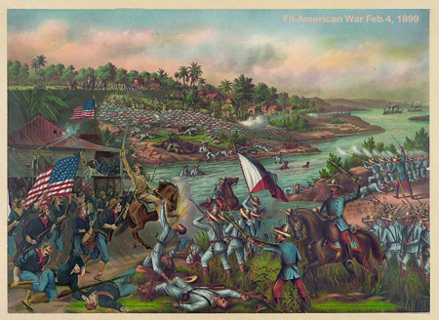
The Battle of Manila: The Battle of Manila, February 1899.
Fighting erupted between U.S. and Filipino revolutionary forces on February 4, 1899, and quickly escalated into the 1899 Battle of Manila. On June 2, 1899, the First Philippine Republic officially declared war against the United States. The war officially ended on July 2, 1902, with a victory for the United States. However, some Philippine groups led by veterans of the Katipunan continued to battle the American forces. Among those leaders was General Macario Sakay, a veteran Katipunan member who assumed the presidency of the proclaimed “Tagalog Republic,” formed in 1902 after the capture of President Emilio Aguinaldo. Other groups, including the Moro people and Pulahanes people, continued hostilities in remote areas and islands until their final defeat a decade later at the Battle of Bud Bagsak on June 15, 1913.

Impact and Legacy
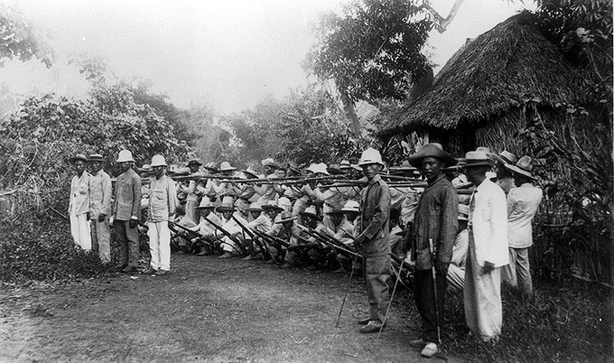
Filipino soldiers: Filipino soldiers outside Manila in 1899.
The war with and occupation by the United States would change the cultural landscape of the islands. The war resulted in an estimated 34,000 to 220,000 Philippine casualties (with more civilians dying from disease and hunger brought about by war); the disestablishment of the Roman Catholic Church as the state religion; and the introduction of the English language in the islands as the primary language of government, education, business, and industry, and increasingly in future decades, of families and educated individuals.
Under the 1902 “Philippine Organic Act,” passed by the U.S. Congress, Filipinos initially were given very limited self-government, including the right to vote for some elected officials such as a Philippine Assembly. But it was not until 14 years later, with the passage of the 1916 Philippine Autonomy Act (or “Jones Act”), that the United States officially promised eventual independence, along with more Philippine control in the meantime over the Philippines. The 1934 Philippine Independence Act created in the following year the Commonwealth of the Philippines, a limited form of independence, and established a process ending in Philippine independence (originally scheduled for 1944, but interrupted and delayed by World War II). Finally in 1946, following World War II and the Japanese occupation of the Philippines, the United States granted independence through the Treaty of Manila.

American Opposition
Some Americans, notably William Jennings Bryan, Mark Twain, Andrew Carnegie, Ernest Crosby, and other members of the American Anti-Imperialist League, strongly objected to the annexation of the Philippines. Anti-imperialist movements claimed that the United States had become a colonial power by replacing Spain as the colonial power in the Philippines. Other anti-imperialists opposed annexation on racist grounds. Among these was Senator Benjamin Tillman of South Carolina, who feared that annexation of the Philippines would lead to an influx of nonwhite immigrants into the United States. As news of atrocities committed in subduing the Philippines arrived in the United States, support for the war flagged.

https://history.state.gov/milestones/1899-1913/war

The Philippine-American War, 1899–1902
After its defeat in the Spanish-American War of 1898, Spain ceded its longstanding colony of the Philippines to the United States in the Treaty of Paris. On February 4, 1899, just two days before the U.S. Senate ratified the treaty, fighting broke out between American forces and Filipino nationalists led by Emilio Aguinaldo who sought independence rather than a change in colonial rulers. The ensuing Philippine-American War lasted three years and resulted in the death of over 4,200 American and over 20,000 Filipino combatants. As many as 200,000 Filipino civilians died from violence, famine, and disease.
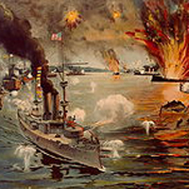
“Battle of Manila Bay”
The decision by U.S. policymakers to annex the Philippines was not without domestic controversy. Americans who advocated annexation evinced a variety of motivations: desire for commercial opportunities in Asia, concern that the Filipinos were incapable of self-rule, and fear that if the United States did not take control of the islands, another power (such as Germany or Japan) might do so. Meanwhile, American opposition to U.S. colonial rule of the Philippines came in many forms, ranging from those who thought it morally wrong for the United States to be engaged in colonialism, to those who feared that annexation might eventually permit the non-white Filipinos to have a role in American national government. Others were wholly unconcerned about the moral or racial implications of imperialism and sought only to oppose the policies of President William McKinley’s administration.
After the Spanish-American War, while the American public and politicians debated the annexation question, Filipino revolutionaries under Aguinaldo seized control of most of the Philippines’ main island of Luzon and proclaimed the establishment of the independent Philippine Republic. When it became clear that U.S. forces were intent on imposing American colonial control over the islands, the early clashes between the two sides in 1899 swelled into an all-out war. Americans tended to refer to the ensuing conflict as an “insurrection” rather than acknowledge the Filipinos’ contention that they were fighting to ward off a foreign invader.
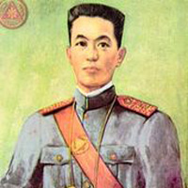
Emilio Aguinaldo
There were two phases to the Philippine-American War. The first phase, from February to November of 1899, was dominated by Aguinaldo’s ill-fated attempts to fight a conventional war against the better-trained and equipped American troops. The second phase was marked by the Filipinos’ shift to guerrilla-style warfare. It began in November of 1899, lasted through the capture of Aguinaldo in 1901 and into the spring of 1902, by which time most organized Filipino resistance had dissipated. President Theodore Roosevelt proclaimed a general amnesty and declared the conflict over on July 4, 1902, although minor uprisings and insurrections against American rule periodically occurred in the years that followed.
The United States entered the conflict with undeniable military advantages that included a trained fighting force, a steady supply of military equipment, and control of the archipelago’s waterways. Meanwhile, the Filipino forces were hampered by their inability to gain any kind of outside support for their cause, chronic shortages of weapons and ammunition, and complications produced by the Philippines’ geographic complexity. Under these conditions, Aguinaldo’s attempt to fight a conventional war in the first few months of the conflict proved to be a fatal mistake; the Filipino Army suffered severe losses in men and material before switching to the guerrilla tactics that might have been more effective if employed from the beginning of the conflict.
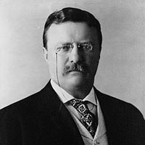
President Theodore Roosevelt
The war was brutal on both sides. U.S. forces at times burned villages, implemented civilian reconcentration policies, and employed torture on suspected guerrillas, while Filipino fighters also tortured captured soldiers and terrorized civilians who cooperated with American forces. Many civilians died during the conflict as a result of the fighting, cholera and malaria epidemics, and food shortages caused by several agricultural catastrophes.
Even as the fighting went on, the colonial government that the United States established in the Philippines in 1900 under future President William Howard Taft launched a pacification campaign that became known as the “policy of attraction.” Designed to win over key elites and other Filipinos who did not embrace Aguinaldo’s plans for the Philippines, this policy permitted a significant degree of self-government, introduced social reforms, and implemented plans for economic development. Over time, this program gained important Filipino adherents and undermined the revolutionaries’ popular appeal, which significantly aided the United States’ military effort to win the war.
In 1907, the Philippines convened its first elected assembly, and in 1916, the Jones Act promised the nation eventual independence. The archipelago became an autonomous commonwealth in 1935, and the U.S. granted independence in 1946.

