Osama Bin Laden and Afghanistan
From Ency. Britannica

Osama bin Laden

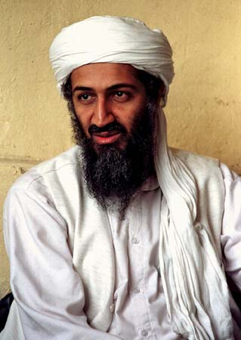
APAP
Osama bin Laden, also spelled Usāmah ibn Lādin , (born 1957, Riyadh, Saudi Arabia—died May 2, 2011, Abbottabad, Pakistan), founder of the militant Islamist organization al-Qaeda and mastermind of numerous terrorist attacks against the United States and other Western powers, including the 2000 suicide bombing of the U.S. warship Cole in the Yemeni port of Aden and the September 11, 2001, attacks on the World Trade Center in New York City and the Pentagon near Washington, D.C.
Bin Laden was one of more than 50 children of Muhammad bin Laden, a self-made billionaire who, after emigrating to Saudi Arabia from Yemen as a labourer, rose to direct major construction projects for the Saudi royal family. By the time of Muhammad’s death in an airplane accident in 1967, his company had become one of the largest construction firms in the Middle East, and the bin Laden family had developed a close relationship with the Saudi royal family.
Osama bin Laden studied business administration at King Abdul Aziz University in Jiddah, where it is likely that he also received instruction in religious studies from Muḥammad Quṭb, brother of the Islamic revivalist Sayyid Quṭb, and Abdullah Azzam, a militant leader. Shortly after the Soviet Union invaded Afghanistan in 1979, bin Laden, who viewed the invasion as an act of aggression against Islam, began traveling to meet Afghan resistance leaders and raise funds for the resistance. By 1984 his activities were centred mainly in Afghanistan and Pakistan, where he collaborated with Azzam to recruit and organize Arab volunteers to fight the Soviet occupation. Bin Laden’s financial resources, along with his reputation for piety and for bravery in combat, enhanced his stature as a militant leader. A computer database he created in 1988 listing the names of volunteers for the Afghan War led to the formation that year of a new militant network named al-Qaeda (Arabic: “the Base”), although the group remained without clear objectives or an operational agenda for several years.
In 1989, following the Soviet withdrawal from Afghanistan, bin Laden returned to Saudi Arabia, where he was initially welcomed as a hero, but he soon came to be regarded by the government as a radical and a potential threat. In 1990 the government denied his requests for permission to use his network of fighters to defend Saudi Arabia against the threat of invasion posed by Saddam Hussein’s Iraq. Bin Laden was outraged when Saudi Arabia relied instead on U.S. troops for protection during the Persian Gulf War, leading to a growing rift between bin Laden and the country’s leaders, and in 1991 he left Saudi Arabia, settling in Sudan at the end of the year.

