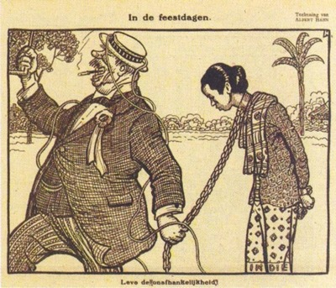
Use this “Overview” grid to get the “big picture” of Dutch colonialism in Indonesia.
For Box 1 use: “Early Dutch Colonialism in Indonesia” worksheet
For Box 2 use: Watch John Green video and do accompanying worksheet
For Boxes 3 to 6 use:
https://www.rijksmuseum.nl/en/explore-the-collection/timeline-dutch-history/1820-1950-indonesia-and-decolonisation

Box 1: Early Dutch colonialism in Indonesia (up to 1816) | Box 2: The decline of the VOC | Box 3: Increasing Dutch state control (including “cultivation system”)
Box 4: Increasing Dutch state control (including “liberal policy”) | Box 5: Increasing Dutch state control (including “ethical policy”) | Box 6: Beginnings of nationalism

