Look at these photos
Can you match them up to the given names?
Ho Chi Minh Ngo Dinh Diem
John F. Kennedy Lyndon B. Johnson
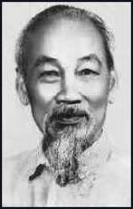 | 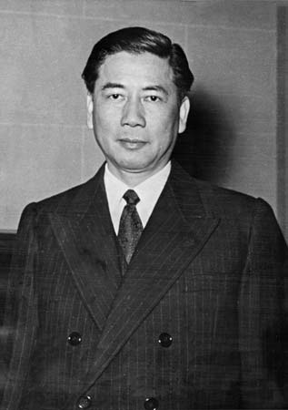
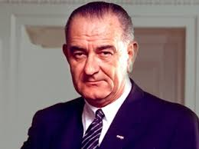 | 