Pristina Airport incident and James Blunt
https://www.theguardian.com/music/2010/nov/15/james-blunt-world-war-three

James Blunt: How I prevented a third world war
Singer claims his refusal to obey an order while serving in the British army in 1999 avoided a major international conflict
Sean Michaels
Mon 15 Nov 2010 10.26 GMT First published on Mon 15 Nov 2010 10.26 GMT in The Guardian
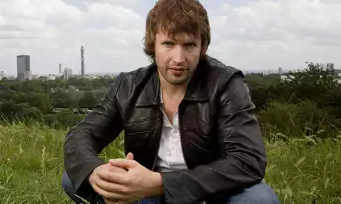
Peacemaker ... James Blunt. Photograph: Alicia Canter for the Guardian
James Blunt apparently prevented a third world war. The singer made the claim in an interview about his military career. "I was given the direct command to overpower ... 200 or so Russians [in Kosovo]," he said. "And the practical consequences of that political reason would be then aggression against the Russians."
The man who later sold 11m albums with a song about a beautiful woman on a subway was once a cavalry officer in the British army, serving among 30,000 Nato troops in Kosovo. The year was 1999, and Blunt was at the head of a column that had been ordered to seize Pristina airfield. "I was the lead officer with [a] troop of men behind [me]," Blunt told Radio 5 Live's Pienaar's Politics. "[It was a] mad situation."
Although US general Wesley Clark had issued a command to "reach the airfield and take a hold of it", the Russians had arrived there first. "We had 200 Russians lined up pointing their weapons at us aggressively," Blunt recalled. "The direct command [that] came in from general Wesley Clark was to overpower them. Various words were used that seemed unusual to us. Words such as 'destroy' came down the radio.
"The soldiers directly behind me were from the Parachute Regiment, so they're obviously game for the fight," Blunt said. But he wasn't willing to risk major conflict with Russia. "There are things that you do along the way that you know are right, and those that you absolutely feel are wrong," he said. "That sense of moral judgment is drilled into us as soldiers in the British army." The singer-songwriter claims he would have declined the order even at the risk of a court martial.
It didn't come to that. British general Sir Mike Jackson sent an admonishing message down the wire. "[His] exact words at the time were, 'I'm not going to have my soldiers be responsible for starting world war three'. [He] told us why don't we sugar off down the road [and], you know, encircle the airfield instead." Asked if he thought the original order could indeed have set off a third world war, Blunt replied: "Absolutely."
Blunt's new album, Some Kind of Trouble, has yet to spark any major international conflicts.

https://www.youtube.com/watch?v=gh41Wxez9PE

There are children standing here
Arms outstretched and to the sky
Tears drying on their face
He has been here
Brothers lie in shallow graves
Fathers lost without a trace
A nation blind to their disgrace
Since he's been here

And I see no bravery
No bravery
In your eyes anymore only sadness
And I see no bravery
No bravery
In your eyes anymore only sadness
Only sadness

Houses burnt beyond repair
The smell of death is in the air
A woman weeping in despair says
He has been here
Tracer lighting up the sky
It's another family's turn to die
A child afraid to even cry out says
He has been here

And I see no bravery
No bravery
In your eyes anymore only sadness
And I see no bravery
No bravery
In your eyes anymore only sadness
Only sadness

There are children standing here
Arms outstretched and to the sky
But no one asks the question why
He has been here
Old men kneel to except their fate
Wives and daughters cut and raped
A generation drenched in hate says
he has been here

And I see no bravery
No bravery
In your eyes anymore only sadness
And I see no bravery
No bravery
In your eyes anymore

Anymore, anymore, anymore

And I see no bravery
No bravery
In your eyes anymore only sadness
And I see no bravery
No bravery
In your eyes anymore only sadness
Only sadness

Attachments area
Preview YouTube video James Blunt - No Bravery [OFFICIAL VIDEO]
James Blunt - No Bravery [OFFICIAL VIDEO]

