Vietnam Source Activity 2 (Year 9)

- What can be inferred from Source A about the reason for American involvement in the Vietnam War?
9 marks (provide a T/S, 3 pieces of evidence and explain each (analysis), a concluding sentence. Good expression. 1 mark for each element)
Source A:
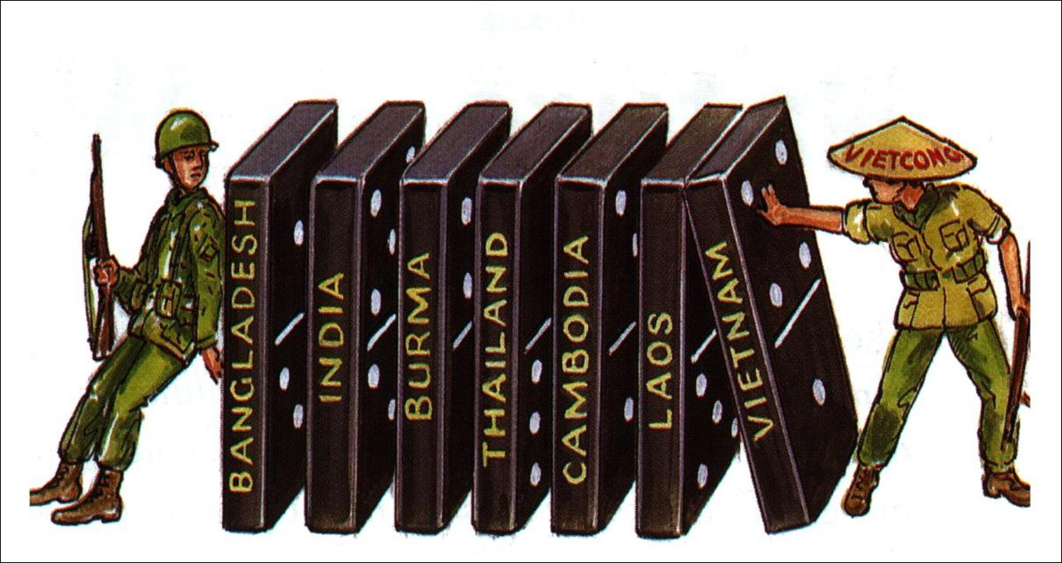
- What can you infer from Source B about the progress of the Vietnam War?
9 marks (provide a T/S, 3 pieces of evidence and explain each (analysis), a concluding sentence. Good expression. 1 mark for each element)

Source B:

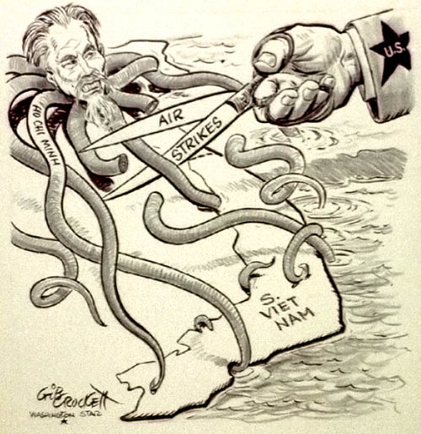

3. Read Sources C and D. Source C and D are about the effects of war on soldiers. Are they about the same effects or different effects?
5 marks (for each source describe 1 effect and give 1 example by using a quotation. Also say if the sources are talking about similar or different effects).

Source C:

This is part of a song called “I was only 19”. It is about an Australian soldier fighting with the Americans in Vietnam.
And can you tell me, doctor, why I still can't get to sleep?
And night-time's just a jungle dark and a barking M16?
And what's this rash that comes and goes, can you tell me what it means?
God help me, I was only nineteen.
A four week operation when each step could mean your last one on two legs
It was a war within yourself.

Source D:
Look of Hatred
Columns of smoke, black and white and tinged with red, ringed the swamp from brushfires and burning villages…From one cluster of huts a burst of rifle fire zinged past the helicopter. Our chopper crew answered with a brace of rockets. Some huts disintegrated…
I rejoined the Rangers, and we walked into a fishing village. On the sand in the shade of a palm grove lay an old woman, her black pyjama suit scorched and tattered. Her face was burned red…Her grandson was spooning water between her lips. I knelt beside them. I shall never forget the look of hatred in his eyes---or lose my own feelings of guilt by association.
J Shaw, Time, 5 February 1973

Answers:

- French, Dien Bien Phu, Kennedy, Tet, All Vietnam becomes communist
- -Asian countries were regarded as dominoes which would fall to communism (dominoes pictured)
-America wanted to stop this (soldier leaning in)
-Enemy was the Viet Cong (gun and name on hat)
3. -Ho Chi Minh - leader - influence everywhere - shown as octopus
-Air strikes to stop Ho- tentacles cut off
-US the main opponent- big hand with scissors

4. Source C:
-effect: can’t sleep (psychological)
OR-effect: rash (physical)
Source D:
-effect: guilt (psychological)
5th mark depends on which effects they chose, as to whether the answer is similar or different

