Look at this cartoon. How does it reflect Cold War tensions in 1961, particularly in relation to Cambodia?
"The Predatory Hands of the 'Free World,'" 1961.
http://johnbrownnotesandessays.blogspot.hk/2017/07/russia-america-and-conspiratorial.html
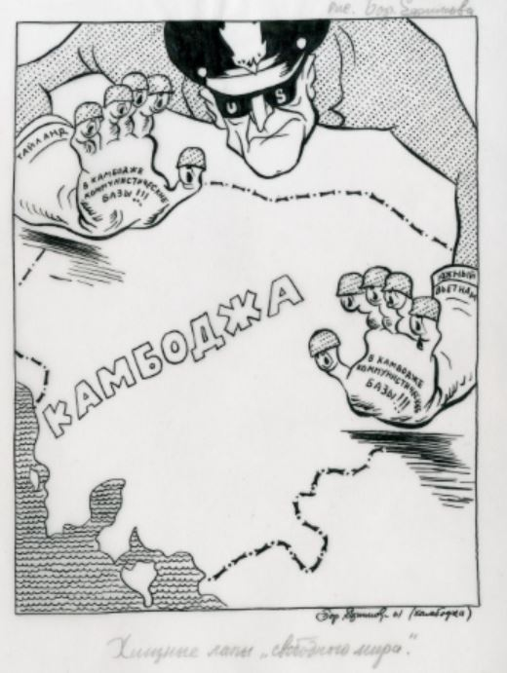
The predatory land-grabbing hands that had once belonged to fascist leaders such as Mussolini turned exclusively American after World War II.
In this 1961 cartoon, an American general eyes Cambodia; his finger puppets bray “there are communist bases in Cambodia,” providing the justification for intervention. His gloves betray a different story, for they are marked “Thailand” and “South Vietnam.” While depicting this rapacious appetite as routine, Efimov is also mocking the 1947 Truman Doctrine, which declared that the United States, as the “leader of the free world,” must provide political, military, and economic assistance to all democratic countries threatened by authoritarianism.

