Tirto Adhi Suryo
One of the fathers of Indonesian Nationalism

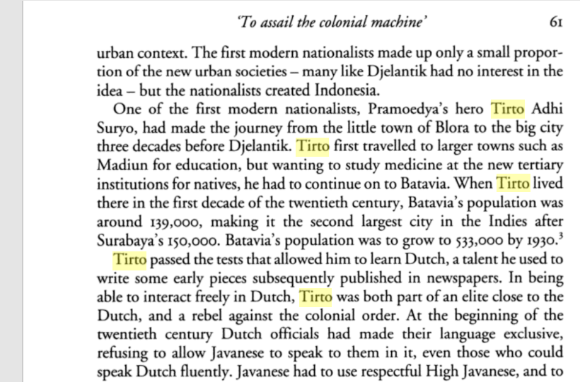
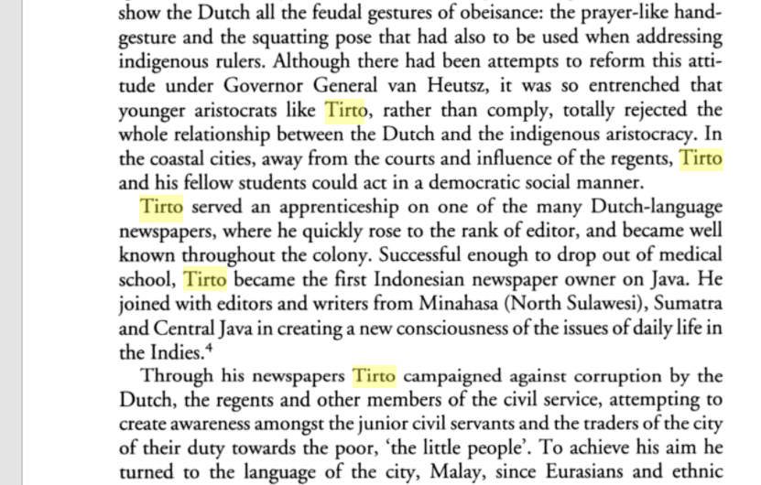
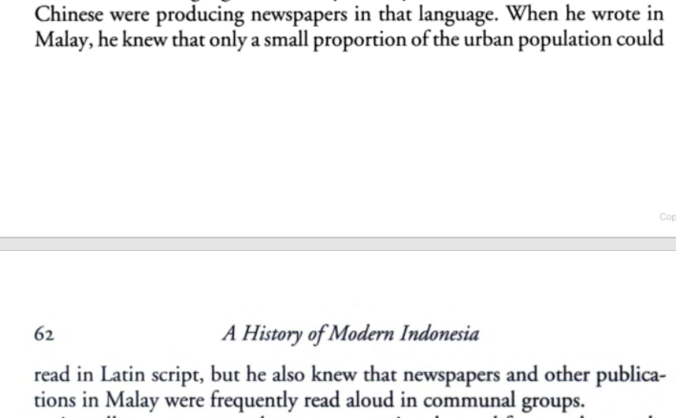
https://books.google.com.hk/books?id=RWrm7tPzs1AC&pg=PA61&lpg=PA61&dq=Tirto+Adisuryo&source=bl&ots=7PSAOoLbjM&sig=ACfU3U1eX_UixKoGGuOSmez6mZ1rSR5ktQ&hl=en&sa=X&ved=2ahUKEwid_8brkJnzAhUXQPUHHWWADy8Q6AF6BAglEAM#v=onepage&q=Tirto%20Adisuryo&f=false

