The Vietnam War – Discoveries & Wonderings
The Geography  of the War  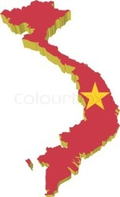 | What have I learned? | What questions do I still have? What would I like to explore further?
The War in  Numbers | What have I learned? | What questions do I still have? What would I like to explore further?
Vietnam:  A Peoples’ War | What have I learned? | What questions do I still have? What would I like to explore further?

