Source A
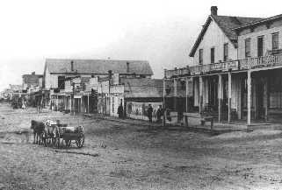
Front Street, Dodge City, KS 1876

Source B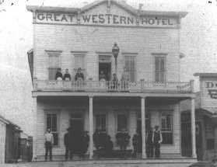

Source C

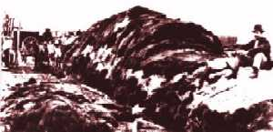
Charles Rath sitting on a pile of buffalo hides. Rath owned Rath & Co., a general outfitting store. He also shipped hides east. This yard held up to 70,000 hides at the time.

Source D
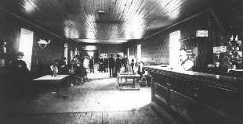Ham Bell's Variety. A saloon (bar) south of the infamous "Dead Line"

Source E
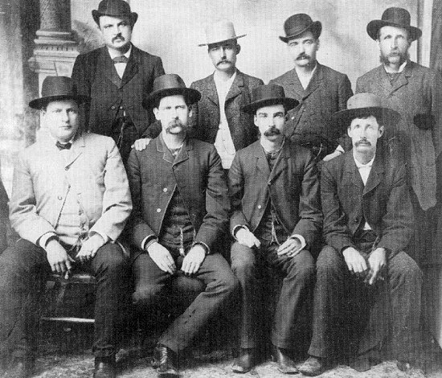
The Dodge City Peace Commission
Source F
The fact is the condition of affairs in Dodge, instead of improving, as I had hoped, seems to be growing worse. I hear, every now and then, of robberies committed on innocent strangers, who have come to Kansas to seek homes. Visitors inform me that the saloons (bars) are increasing, not only in numbers, but in depravity (corrupt, morally evil); and that thieves, desperadoes, gamblers and criminals generally, are multiplying.
John Martin, governor of Kansas, letter to Robert Wright, mayor of Dodge City (5th November, 1885)

Source G
City Marshal Masterson thinks about organising a tramp brigade to clear the streets and alleys of the filth and rubbish that has been building for a year or so. There are about thirty tramps now living among us, all of whom have no visible means of support and are liable to arrest under the vagrant act.
Dodge City Times (30th March, 1878)

Source H
In 1968 Robert Dykstra in his fine book Cattle towns claimed that only forty five killings occurred between 1870 and 1885 and only a few were directly caused by gun-fights between lawmen and cowboys. But since then others have suggested that the total was far higher, especially in Dodge City and Newton.
The Story of the Wild West

Source I
There is seldom witnessed in any civilized town or country such a scene as at the Long Branch saloon, in this city, last Saturday evening, resulting in the killing of Levi Richardson, a well known freighter, of this city, by a gambler named Frank Loving.
From a school text book

Source J
Dodge City, with its collection of saloons, dance halls, gambling houses and brothels, developed serious law and order problems. Boot Hill cemetery gained a reputation as the last resting place of men killed in gunfights.
From a website

