POLITICAL SPECTRUM IN SPAIN 1930s
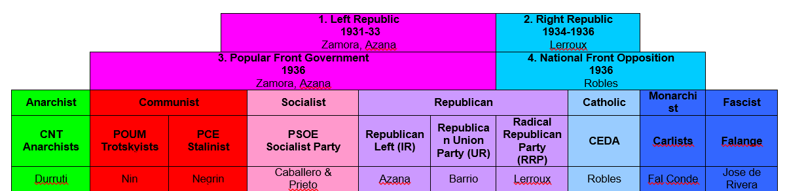
REPUBLICANS – Basically comes to mean those who support the left wing government of the Popular front (however, some of these are revolutionary vs democracy)
NATIONALISTS – Those who believe in authoritarian government, usually aiming at upholding traditional authority (however, some alternative revolutionary ideologies, like the fascist Falange)
Key point: Both sides have a spectrum of opinion within them – their ability to create unity with their own group will be a key factor in explaining their relative success in the civil war.

A – WHAT WERE THE KEY EVENTS OF THE SPANISH CIVIL WAR?
1. Info Grab. With a partner make sure you capture all the key events – put them all in the first column to start with (video, then HS article, then Reading 2)
2. Cut and paste events into the ‘good for the republic’ & ‘bad for the republic’ columns.
3. Looking ‘East and West’ rather than just ‘North to South’. Make connections with other events that have been going in the 1930s in the international context – think about why interventions may have happened when they did in the context of other events.
4. Extension: Copy and paste a blank map of Spain from Google Images into this tool and annotate with events from the timeline below. Make sure you save as a pdf OR use StoryMap for ARCGIS (log in and password should be same as your school ones).

 |  | Good News for the Republicans/Bad news for the Nationalists | Bad News for the Republicans/Good for Nationalists | International Events
1936 | July
 | Aug
 | Sept
 | Oct
 | Nov
1937 | Feb
 | Mar
 | April
 | May
 | June
 | July
 | Aug
 | Dec
1938 | Feb
 | April
 | May
 | Jul
 | Oct
 | Dec
1939 | Jan
 | Feb
 | Mar
 | Apr

B. WHY DID FRANCO WIN THE CIVIL WAR? / HOW IMPORTANT WAS FOREIGN INTERVENTION?
Imagine one of the above is an essay question. Below are 9 key reasons why Franco won the Spanish Civil War (in no particular order).

a) Categorise under three thematic headings of your choosing – discuss these with me.
b) Develop each point with information from the table and further reading (your textbook / other resources).
c) Identify interpretations around the overall question.
Pick one that you agree with and summarise in bold at the bottom.
d) Now delete all the instructions from this document and you have a clear summary of the key issues.
REASONS FOR NATIONALIST VICTORY IN SPANISH CIVIL WAR
1. The Nationalists controlled the main agricultural areas from the outset, so Franco’s troops were better fed than the republicans

2. Franco named himself the “Head of State” and abolished rival political parties within the Right (the Carlists and the Falange)

3. The Republic relied heavily upon International Brigades from the West and 500 military advisors from the USSR – but these groups distrusted each other.

4. The Republican parties (anarchists, communists and socialists) were so divided that they started fighting each other in the “Barcelona Uprising” of 1937

5. Hitler sent 20 transport planes to get Franco’s forces from Morocco to Spain and then sent 600 bombers (the Condor Legion) who bombed Guernica.

6. The Republicans could not decide whether farms should be nationalised or privatised – so production fell, food prices trebled and rationing was introduced.

7. Germany helped Franco to present himself as the defender of Spain against communism.

8. Nazi Germany obtained 75% of Spain’s mining shares under the 1938 Montana Project in return for urgent military assistance.

9. Franco named himself ‘Generalissimo’ and brought the private armies of the right-wing parties (e.g. the Carlists and the Falange) under his control.

