The Cuban Missiles Crisis: Causes
▪ The Cuban Missile crisis was the most dramatic and dangerous moment of the Cold War.
• It is the time when the world came nearest to annihilating itself in a nuclear holocaust which would have meant the end of civilisation.

The three key figures involved in the crisis were Fidel Castro of Cuba, Nikita Khrushchev of the Soviet Union and John F. Kennedy of the United States:
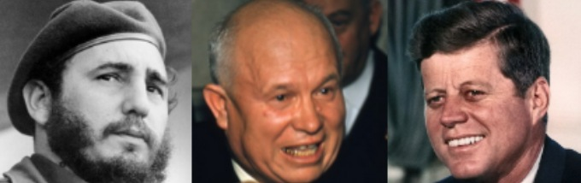

Cause 1. Tension between USA and USSR

a. The Arms Race
▪ 1945: Atom Bomb produced by the USA; USSR follows with its own in 1949.
• 1952: Hydrogen Bomb produced by the USA; the USSR followed suit the next year.
• 1957: ICBM (Inter-continental ballistic missile) developed by the USSR, which could reach the USA from a firing point in the USSR; The USA responded with their own ICBM (the Atlas) soon afterwards, which they placed in Turkey.
• 1958: Sputnik 1 (the first earth satellite) launched by the USSR; the USA launched their own a few months later.

b. Hot Spots
East and West had also come very close to direct conflict on a number of occasions since 1945.

Task
▪ Use the presentation earlier used by the teacher, and any other sources available to you, to complete this table.
 | Cause of the crisis | Events | Consequences
Berlin Blockade (1949)
Korean War (1950-53)
Cuba (1959)
Berlin Wall (1961)
Watch the first video clip (link at the end of the worksheet) and make extra notes.

Cause 2. Tension between USA and Cuba

a. Fidel Castro gets friendly with the USSR
• 1959: the Communist Fidel Castro took power in Cuba, an island situated off the coast of America.
• 1960: U2 Spy Plane Incident: The USSR shot down an American Spy Plane over Soviet territory. Khrushchev denounced the USA and her allies at the United Nations in a blistering speech.
• 1960: Castro made a trade agreement with Russia: Cuba sent sugar to Russia in return for oil, machines and money. The Americans reacted by stopping all trade with Cuba. In retaliation, Cuba nationalised all of its American-owned companies.
Watch the second video clip (link at the end of the worksheet) and make extra notes.

b. The USA reacts: The Bay of Pigs and Operation Mongoose
• 1961: In January, John F. Kennedy becomes President of the United States.
• 1961: In April, the CIA encouraged, funded and transported an attempt by anti-Castro Cuban exiles to invade Cuba at the Bay of Pigs. It failed miserably, greatly embarrassing President Kennedy.
• 1961: In June, Kennedy and Khrushchev met for the first time at the Vienna Summit. Kennedy’s embarrassment about the Bay of Pigs convinces Khrushchev that he is a weak President.
• 1962: The US Armed Forces conducted a mock invasion of a Caribbean island to overthrow a fictitious dictator whose name, Ortsac, is Castro spelled backwards. Additionally, the U.S. drafted a plan to invade Cuba (Operation Mongoose). This is all devised to keep Castro nervous.
• 1962: Both Castro, and also the Soviet foreign minister Gromyko, warn that another attack on Cuba would mean a war with the USSR.

Watch the third and fourth video clips (link at the end of the worksheet) and make extra notes.

Homework / Extension Task
The three most important figures in the Cuban Missile Crisis were the leader of Cuba, the USSR and the USA. Conduct your own research about each using this table. In this way you will be in a much better position to understand their actions in subsequent lessons.

 |  | Background / Early Life | Rise to Power | Personality | Beliefs
Cuba | Castro
USSR | Khrushchev
USA | Kennedy

http://goo.gl/YUu2Ot
Video Clips to accompany the worksheet

