1. Why did the French leave Indo-China?
1. This is a map of the countries that were included in French ‘Indo-China’. Insert shapes to label them using this map, you can also insert symbols to represent other geographical features:
http://www.pbs.org/wgbh/amex/vietnam/maps/map_pop_01.html

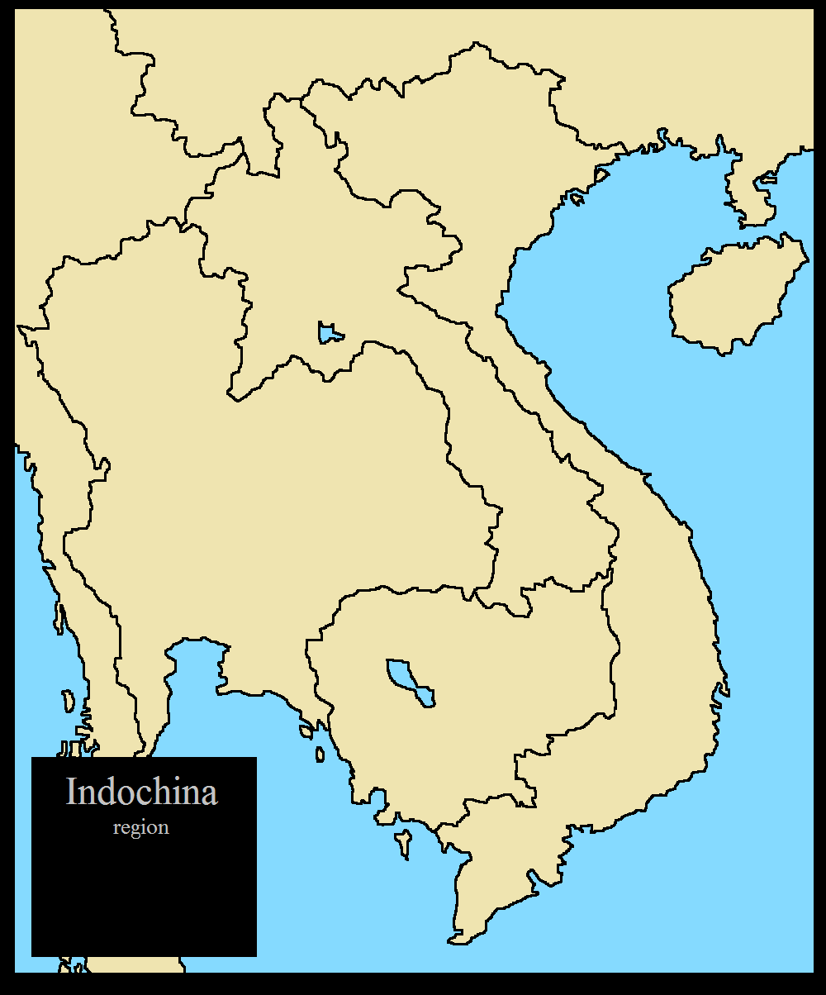
Key:

2. Use this site – summarise who Giap is:

3. Creating a Battle Plan.
In 1954 the French army fought a battle at Dien Bien Phu. They aimed to crush the Vietminh (the communists based in North Vietnam). However, things did not go to plan…
Read the Dien Bien Phu information sheet. Your job is to reconstruct a plan of the battle – the aim is to show what factors led to the defeat of the French. Your teacher will show you an example. You could:
- Draw, photograph and insert on your website
- Use Google Draw / other programme
- Record an interview with the French commander etc (discuss with your teacher).

