“Look at me and look at the earth. It was our father’s and should be our children’s after us....
If the white men take my country, where can I go?
I have nowhere to go.
I cannot spare it, and I love it very much. Let us alone.”
—Sitting Bull, Lakota Sioux chief, 1877
Source A

“I am inclined to think that the occupation of this region of the country is not necessary to the happiness and prosperity of the Indians, and as it is supposed to be rich in minerals and lumber it is deemed important to have it freed as early as possible from Indian occupancy.”
—Columbus Delano, secretary of the interior, 1872
Source B

Source C

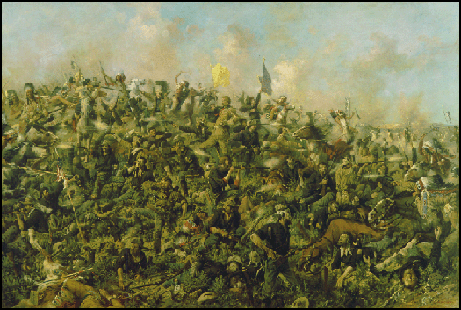
Edgar Paxson, Custer’s Last Battle of the Little Bighorn (1899)

Source D
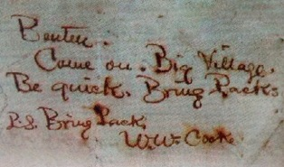

Benteen.
Come On. Big Village. Be quick. Bring Packs.
P.S. Bring packs. W.W. Cooke

