‘I must study war and politics that my sons may have liberty to study mathematics and Philosophy’ – John Adams

International Baccalaureate- Global Politics SL / HL
(First examination May 2018)

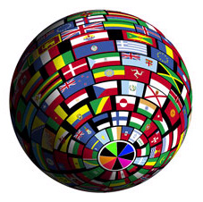

Diploma Programme - Course Companion

The I.B Global Politics Diploma Programme at West Island School

The 21st century is characterised by rapid change and increasing interconnectedness, impacting individuals and societies in unprecedented ways and creating complex global political challenges. Global Politics is an exciting, dynamic subject that draws on a variety of disciplines in the social sciences and humanities, reflecting the complex nature of many contemporary political issues. The study of global politics enables students to critically engage with different and new perspectives and approaches to politics in order to comprehend the challenges of the changing world and become aware of their role in it as active global citizens.
The Diploma Programme Global Politics course explores fundamental political concepts such as power, equality, sustainability and peace in a range of contexts. It allows students to develop an understanding of the local, national, international and global dimensions of political activity and processes, as well as to explore political issues affecting their own lives. The course helps students to understand abstract political concepts by grounding them in real-world examples and case studies. It also invites comparison between such examples and case studies to ensure a wider and transnational perspective.
The core units of the course together make up a central unifying theme of “people, power and politics”. The emphasis on “people” reflects the fact that the course explores politics not only at a state level but also explores the function and impact of non-state actors, communities, groups and individuals. The concept of “power” is also emphasised as being particularly crucial to understanding the dynamics, tensions and outcomes of global politics. Throughout the course, issues such as conflict, migration or climate change are explored through an explicitly political lens: “politics” provide a uniquely rich context in which to explore the relationship between people and power.

How is the I.B Global Politics Programme Structured?

- Global Politics is in Group 3, ‘ Individuals and Societies’

- Global Politics is available at both Standard and Higher level

- Higher Level and Standard Level students both complete Paper 1 and Paper 2, while HL students also complete an additional question in Paper 2. All students complete coursework, called the ‘Engagement Activity’, HL students are additionally required to submit two recorded presentation. The table overleaf summarises the assessment structure.

Title | Exam Paper | Exam Questions Focus | Weighting  SL HL
Stimulus-based paper on a topic from one of the four core units  1. Power, sovereignty & international relations  2. Human Rights  3. Development  4. Peace & conflict | Paper 1  SL & HL | Document Study  Answer all 4 short answer/structured questions in 1 hr 15 minutes | 30% 20%
People, Power & Politics  1. Power, sovereignty & international relations  2. Human Rights  3. Development  4. Peace & conflict | Paper 2  SL & HL | Broad Questions  SL: 2 x Essays in 1hr 45 minutes  HL: 3 x Essays in 2hr 45 minutes  (from different topics) | 45% 40%
Engagement Activity | Internal Assessment  SL & HL | HL & SL: Action and research project  1500 - 2000 Words  HL only: In addition, students complete the ‘Global Political Challenges’ – two recorded oral presentations of two case studies chosen from the two different HL extension topics | 25% 20%  20%

Course Options and Exam Units

The course is designed to teach the political theories of the four core units through a range of carefully selected case studies. Students will build, develop and challenge these concepts through examination of their operation in the context of actual contemporary world events and issues. The table overleaf is an example of such a structure (the specific world issues you will focus on will change according to what is happening in the world):

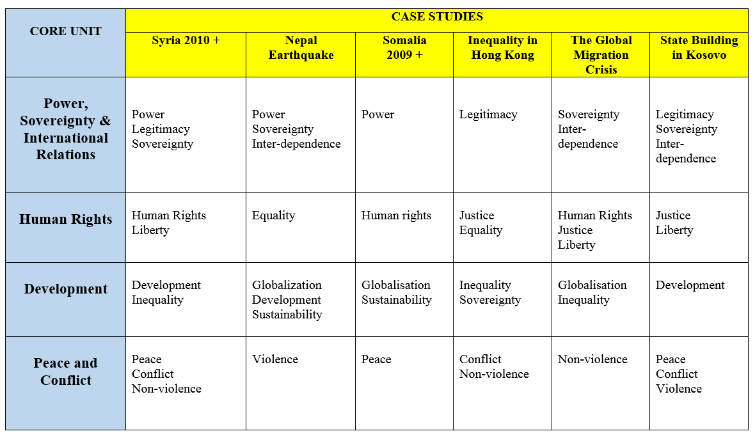

Higher level students also examine two contemporary global political challenges through self-selected case studies. Two challenges must be studied from the following six options:

• Environment • Poverty • Health • Identity • Borders • Security

Students then submit two ten minute recorded presentations where they discuss a relevant issue based in one of their case studies.

The Engagement Project

All standard level and higher level students complete a common internal assessment task, which gives them an opportunity to explore the central unifying theme of the course—“people, power and politics” —in practice. Students undertake an engagement activity, such as interviewing policymakers on a development theme, participating in a simulation (e.g. MUN) or organizing an awareness-raising campaign on human rights. In their assessed written report, they examine a political issue they learned about through the activity, their study of global politics and further reading.

HL Oral Presentations

They also submit for external assessment a video-recorded oral presentation where they discuss a political issue embedded in each of the two global political challenges that they have selected.

Go the WIS Global Politics website for an example of a student presentation from the IB.

What does a unit look like – how does the theory meet the case study?

 | Syria 2010-present
Key concepts | Power, legitimacy, sovereignty, human rights, liberty, development, inequality, peace, conflict, violence, non-violence
Prescribed content | - Foundational unit: Definitions and theories of power; The evolving nature of state sovereignty; Legitimacy of state power; The UN; IGOs; NGOs; Social movements, resistance movements and violent protest movements; Legitimacy of non-state actors; Global governance; Cooperation: treaties, collective security, strategic alliances, economic cooperation, informal cooperation; Conflict: intrastate war, terrorism  - Human rights unit: Definitions of human rights; The UNDHR (1948); Developments in human rights over time and space; Human rights laws and treaties; Protection and enforcement of human rights on different levels; Monitoring of human rights agreements; Claims on human rights; Violations of human rights; Individual vs. collective rights; Universal rights vs. cultural relativism; Politicization of human rights  - Development unit: Different definitions of development, including sustainable development and well-being; Political factors; Economic factors; Social factors; Institutional factors; Approaches for developing society  - Peace and conflict unit: Different definitions of peace, conflict, and violence including positive peace and structural violence; Types of conflict; Justifications of violence, including just war theory; Causes of conflict; Parties to conflict; Manifestations of conflict, including non-violence; Conflict dynamics; Third-party involvement in conflict, including humanitarian intervention.

