Rwandan Revolution and Independence 1959-62  (PARMEHUTU, UNAR, KIGELI V, TUTSI REFUGEE, 1959 MASSACRES, RPF, INDEPENDENCE) P.G. 31 | Definitions: People and Groups | Key Geographical Features of Rwanda  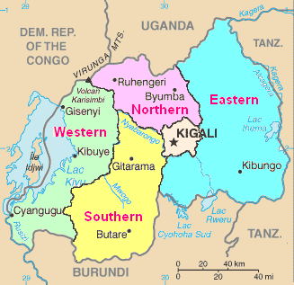
The First Republic 1963-73: Kayibanda  (HUTU DOMINANCE, DEISCRIMINATION, UN/FOREIGN, INYENZI, TUTSI REBEL ACTIVITY AND CONSEQUENCES, GKONGORO, REGIONALISM/CORRUPTION/RACISM)P.G. 34 | Key Economic and Social Features of Rwanda
The Second Republic 1973-90: Habyarimana  (HABYARIMAN RISE, IMPACT EVENTS IN BURUNDI, MOVE TO UNITY, MRND, ‘PROGRESS’, IMPACT EDUCATION REFORMS) P.G. 34-35 |  | Judgment: How did the period 1962-90 contribute to the development of ethnic tension?

