A - YUGOSLAVIA IN THE COLD WAR | 5 KEY POINTS:  1. By 1948 Tito and Stalin had split due to Tito’s attempts to establish a local communist bloc.  2. Hoxha came to power in Albania creating tension with Tito, especially when he followed Maoism. By 1985 Albania was an economic and social mess.  3. Tito created a system of ‘self-management’ so the republics in Yugoslavia could rule themselves, thus preventing dominance by any one group.  4. Tito’s personal skills and prestige were massive – while he was around nationalist movements were crushed.  5. Tito sought to balance the power of Serbia by promoting the other ethnic minorities – in 1974 he granted Kosovo equal status to the other republics | C - TITO’S RULE IN YUGOSLAVIA
B - ALBANIA IN THE COLD WAR | 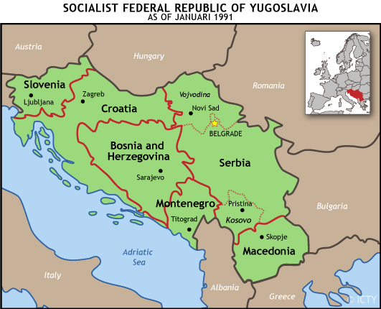
WEIRD HISTORY:  Use the ‘Weird History’ resources on the Weebly | ANALYSIS: If Tito’s rule was so peaceful, why can it be seen as a cause of later conflict?

