In the new syllabus, it is possible that Primo de Rivera may be the topic of a question in his own right – hence this summary.
However, he is more likely to come up as part of the causes of the Spanish Civil War = while he has some early success, he ultimately contributed to the polarisation in Spanish politics that was to become insurmountable during the Second Republic.
Key events:
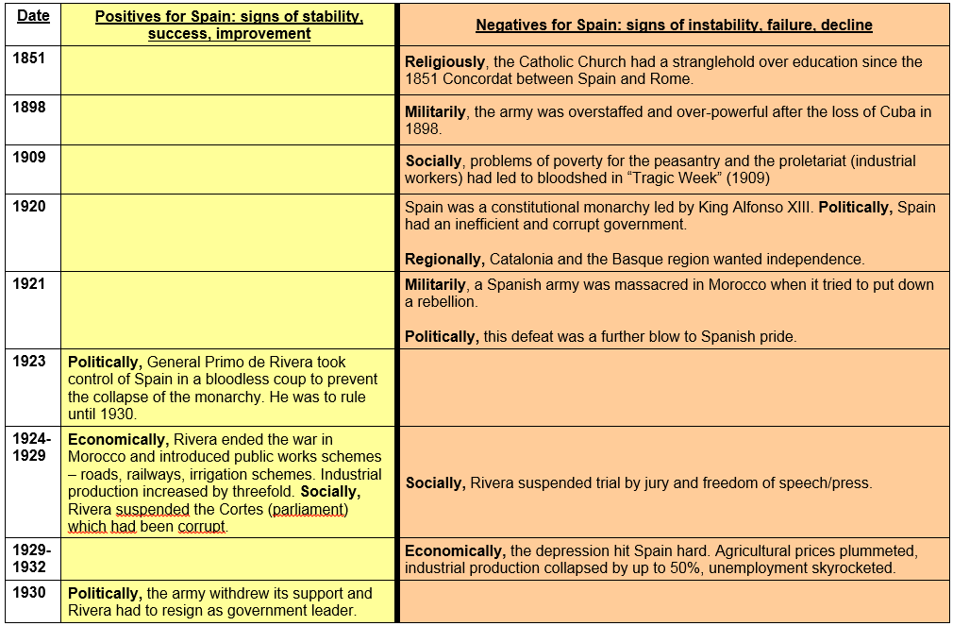
Key Policies:
 | 1. Successes | 2. Failures
1. Regional | • Primo initially created a Catalan regional assembly and planned to do the same in the Basque Country. Basque / Catalan books were tolerated. | • Early concessions granted to Catalonia were withdrawn and their flag was banned when it became clear that the new assembly would not be a bulwark of support for his regime.
2. Socio-Economic | • Roads, irrigation schemes, railway network across the Pyrenees into France, 2000 new schools built.  • Compulsory arbitration of labour disputes to improve relations between bosses and workers built on previous voluntary schemes. | • Finance Minister Sotelo failed to reform the tax system; this meant reliance on foreign loans and credit, which left the country more vulnerable to the effects of the Great Depression after 1929.  • Arbitration scheme did not extend to countryside due to landowner opposition.
3. Political | • Primo supported the socialist trade union movement (UGT), set up a new “Patriotic Union” party ('Spain – One and Great!') with the aim of uniting the people and established a “National Assembly” to listen to the people. | • Primo banned the Anarchist trade union movement (CNT); the UGT refused to join his National Assembly, which was seen as less powerful than the Cortes he had dissolved; and his 'Patriotic Union' party never gained much of support.
4. Military | • War with Morocco won (with French assistance) in 1926.  • Primo's introduction of promotion by merit was popular with the Africa Corps. | • The promotion by merit scheme was deeply unpopular with the powerful Artillery Corps, who attempted a coup against Primo in 1928.  • War in Morocco a serious drain on resources; Primo had hoped to withdraw peacefully with a negotiated settlement but the army had opposed his plan.
5. Religious |  | • Degrees awarded by Catholic universities were given official recognition – controversial…

Analysis:
“Primo de Rivera was responsible for his own downfall.” To what extent do you agree?
Although he cannot be considered entirely responsible due to external influences that were outside his control, his policies exacerbated the long-term problems of Spain and thus he did contribute to his downfall.

1. Primo’s military errors affected the socio-economic problems present in Spain
- War with Morocco: the ‘promotion by merit’ scheme was unpopular with the Artillery Corps, resulting in a coup in 1928 (suggests that Primo was incapable of retaining the support of his strongest support bases, has the potential to undermine his power)
- Loses support from colonialists like Franco
- Great Depression drains resources - Primo loses the backing of the army

2. His policies to improve socio-economic situation were doomed to fail when coupled with the aforementioned military problems
- “Kerosene to Electricity” (schools, rail networks, roads) + labour disputed abated (suggests that there were policies made him more popular than would be expected given his downfall; he was not entirely responsible)
- Increased Catholic influence in education was controversial + stratified the intellectual aspects of Spanish society
- Relied on foreign loans and failure to reform the tax system however made the country vulnerable to the Great Depression (which resulted in drops in the agricultural and industrial sectors), which created an atmosphere appropriate for Primo’s downfall

3. Primo intensified the pre-existing political divisions in Spain, which made his downfall inevitable
- Support trade unions, however the UGT refused to join Primo’s National Assembly which was deemed less capable than the Cortes
- Nevertheless, his inability to match the different ideological contexts of each individual political movement was not necessarily unprecedented, as doing so was not within his capacity (reduces the extent to which he was responsible for his downfall)
- Implemented strict censorship and banned the Anarchist (CNT) movement to eliminate labour violence or support for radical liberals and socialists (more conservative and exclusive, did not facilitate the other parties and appease their movements, increasing positive reception to his downfall)
- Unsuccessful policies in Catalonia and Basque (regions wanting independent rule) made the regional discrepancies more apparent, demonstrating his inability to minimize social problems

