QUIZ
Start the section with a quiz to remind yourself what has happened so far and get an idea about what happened once Castro was in power
Watch the video (in folder or https://www.youtube.com/watch?v=toso9UP6bno) What if Castro never came to power?”
For each picture, write a note about the event it represents
How many did you get right?
Use your friends to help you fill in any you missed
What do you understand as the main issues of Castro’s rule (both positive and negative)? Have 3 points for positive and 3 for negative. Discuss. Write your answers in the bottom boxes of this sheet.

Picture | Explanation
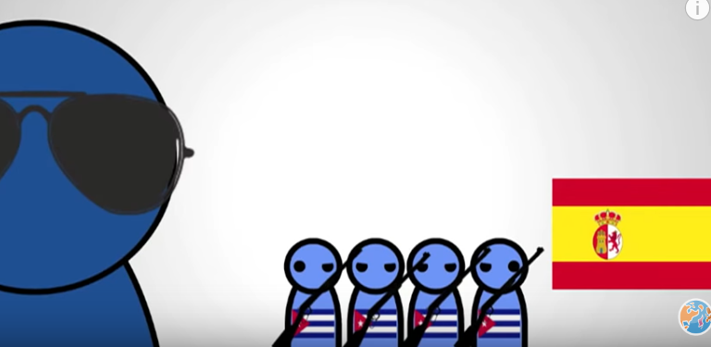
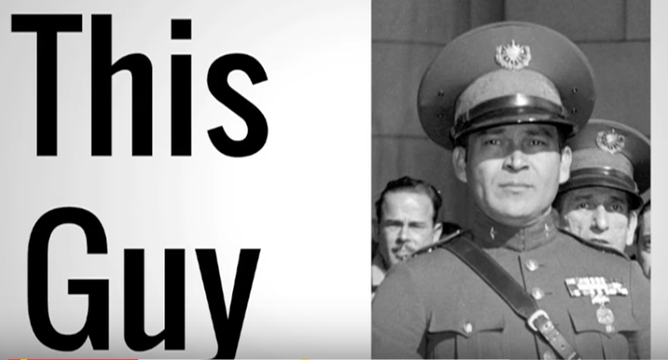
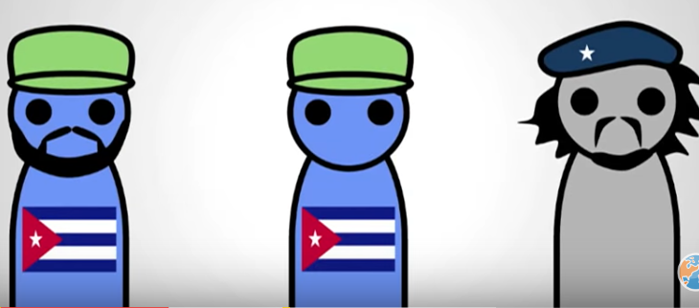
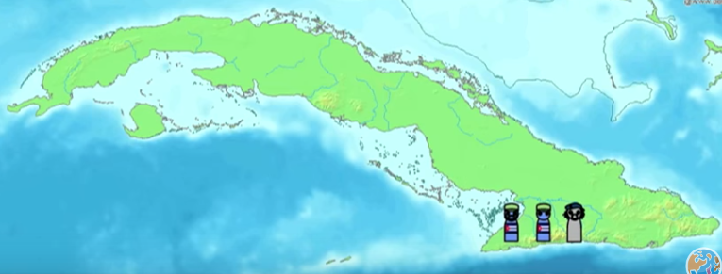
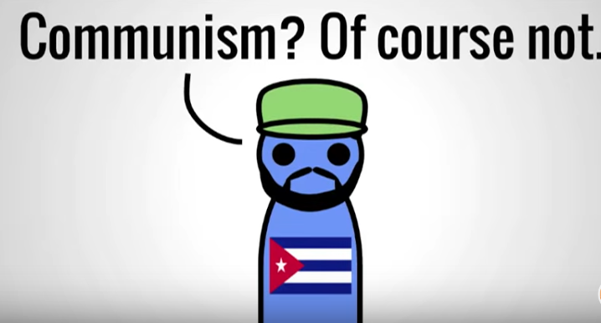
What happened next? From this timeline and the suggestions for the alternate timeline, sort out what Castro DID do
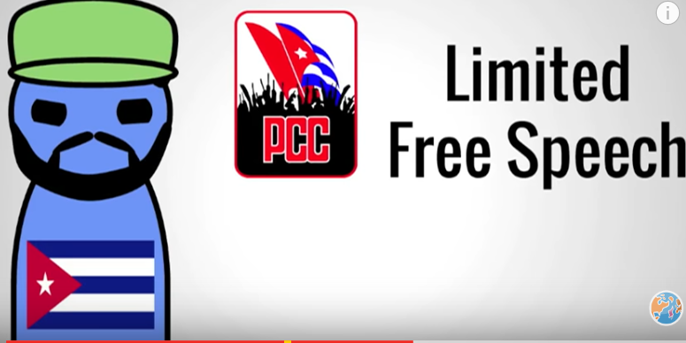
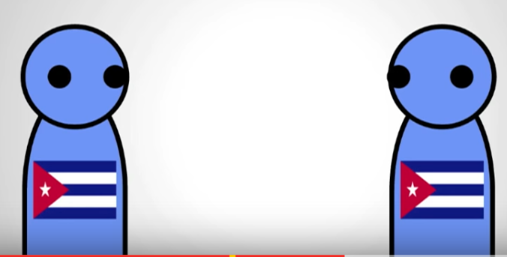
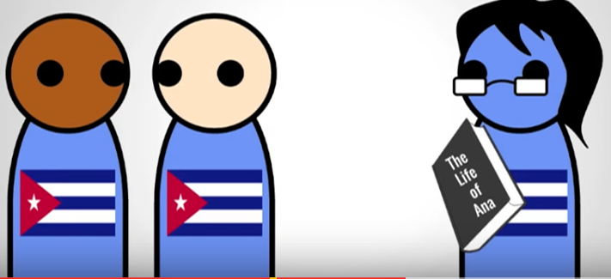
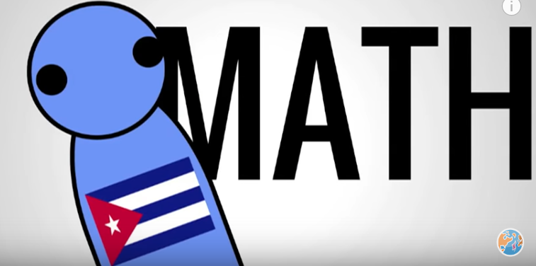
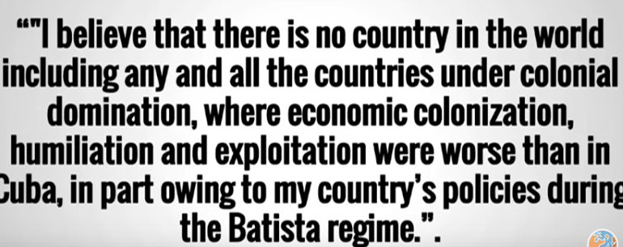
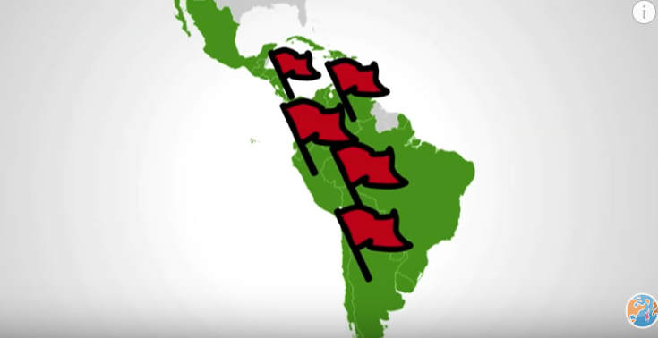
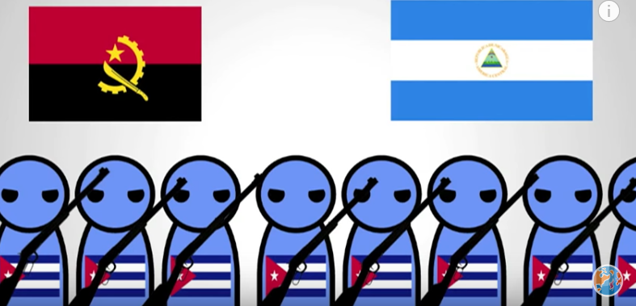
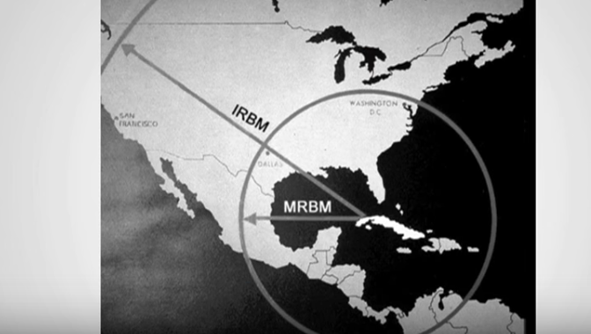
Positives of Castro’s rule | Negatives of Castro’s rule

