Castro’s Rise to Power

Overview
• Ideally, before starting this topic you should have completed the ActiveHistory.co.uk study unit on “What are the most common methods and conditions by which single-party state rulers emerge?” that can be found here.
• The outcome of that unit was an essay which summarised your essential thoughts on why dictators emerge.

Task 1: Comprehension
• Read through the following information and use it to make a list of (a) Methods and (b) Conditions which helped Castro rise to power. Identify links between these factors.

Task 2: Video Notes
• Make additional notes from the online video documentary (there are teacher notes available for this too).

Task 3: Other Tasks
Complete one or more of the following tasks.
• List all the people who helped Castro rise to power. Divide them between the class and get different students to research each one in more detail.
• Produce a Diamond diagram to decide upon the most important factors relating to Castro’s rise to power.
• Produce a news announcement from (a) A supporter of Batista and (b) A supporter of Castro announcing the 1959 Revolution and explaining why it has happened.
• Test your knowledge using this 20-question factual test.

Task 4: Conclusions
• If you completed the ActiveHistory study unit on the rise of dictators, develop your earlier essay with reference to Castro.
• Otherwise, write an essay answering the question “To what extent were economic factors responsible for Castro’s rise to power?”

Who is Fidel Castro, and why did he become a revolutionary?

Early Life

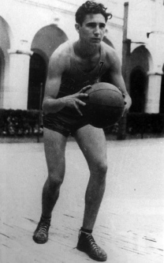
Priviliged upbringing… but also a sense of social injustice
▪ Fidel Castro was born in August 1926.
▪ His father was a wealthy farmer in the east of Cuba.
▪ He was educated privately in Jesuit schools and was a fine athlete.
▪ He read law at Havana University from 1945.
▪ On the other hand, Castro was born illegitimate and was not baptised until the age of 8. This might help to explain why he felt an outsider even despite coming from a relatively privileged background.

Political development
▪ Whist at university Castro became actively involved in student politics, eventually joining the Ortodoxos Party of Eddie Chibás (pictured), a charismatic figure who ran for president against the corrupt president Ramón Grau San Martín.
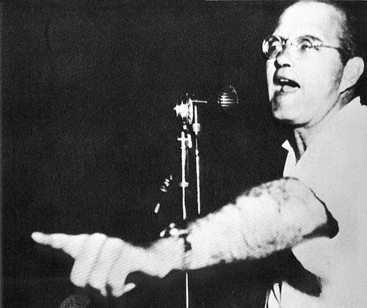
▪ The Partido Ortodoxo was passionately nationalistic and deeply opposed to the influence of the United States on Cuban internal affairs.
▪ In 1948, Castro married Mirta Diaz Balart, a student from a wealthy Cuban family. Mirta's father gave them tens of thousands of dollars to spend on a three-month New York City honeymoon.
▪ In 1950, Castro graduated from law school with a Doctor of Laws degree and began practicing law in a small partnership in Havana.
▪ In 1951, Chibás committed suicide during a radio broadcast and Fidel became even more determined to gain political power.
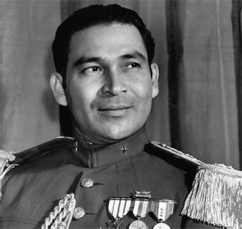
▪ 10 March 1952: General Batista (pictured), acting with the support of the United States, seized power in a coup. Castro formally charged Batista with violating the constitution. However, his petition, entitled Zarpazo, was denied by the Court of Constitutional Guarantees and he was not allowed a hearing. In the years that followed, the Batista regime became a byword for corruption. Large proportions of Cuba’s wealth were exploited by American interests and corrupt Cuban politicians.

How did Castro seize power?

Moncada Barracks Attack
▪ On 26th July 1953, Castro led a botched attack on the Moncado military barracks. Batista's largest garrison outside Santiago de Cuba. Castro defended himself at his trial, publicising his policies in his famous speech History Will Absolve Me. Castro was found guilty and imprisoned on Isla de Pinos, where he reconsidered his strategy. He reached the conclusion that underground guerrilla warfare tactics were more likely to succeed that a coup d’etat.
“Marxism taught me what society was. I was like a blindfolded man in a forest, who doesn't even know where north or south is. If you don't eventually come to truly understand the history of the class struggle, or at least have a clear idea that society is divided between the rich and the poor, and that some people subjugate and exploit other people, you're lost in a forest, not knowing anything”
— Fidel Castro on discovering Marxism, 2009
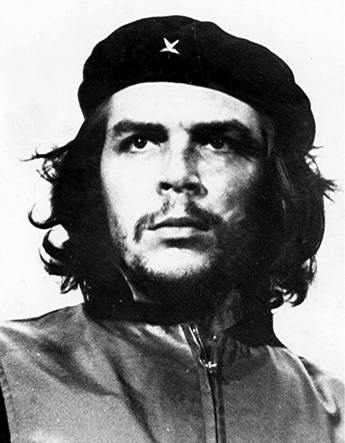
▪ In 1955 Castro was was released as a result of a political amnesty, at which point he left for Mexico. Here, he reunited with other Cuban exiles and founded the 26th of July Movement. He also came under the influence of Ernesto ‘Che’ Guevara (pictured).
▪ In 1956, Castro returned to Cuba. By this time he had moved further to the left, influenced by the communist writings of Marx, Engels, and Lenin. He came to see Cuba's problems as a direct result of capitalism, the "dictatorship of the bourgeoisie". He adopted the Marxist view that meaningful political change could only be brought about by proletarian revolution.

26th July Movement
• November 26, 1956: Castro and his group of 81 followers set out from Tuxpan, Veracruz, aboard the yacht Granma for the purpose of starting a rebellion in Cuba.
• December 2, 1956: The rebels landed at Playa Las Coloradas. Most of Castro's men were killed or taken prisoner by Batista's forces and the rest fled to the Sierra Maestra mountains. The group of survivors included Fidel Castro, Che Guevara and Raúl Castro, Fidel’s brother.
• February 24, 1957: Herbert Matthews from the New York Times (below, with Castro) publishes the first of several articles after interviewing Castro in the Sierra Maestra. These were followed by a number of television interviews which raised his profile in the USA.
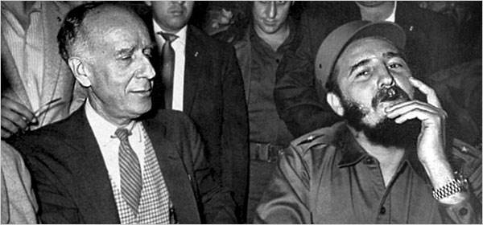

• July 12, 1957: Castro also signed the Manifesto of the Sierra Maestra in which he agreed to restore all of the provisions of the 1940 Constitution that had been suspended under Batista and to hold elections within the first 18 months of his time in power.
▪ March 1958: The USA, concerned about Batista’s use of weapons against his own people, cut off military aid to the Cuban government.

Operation Verano
▪ May 1958: Batista launched a series of attacks on Castro’s forces. Although heavily outnumbered, Castro's guerrilla forces (known as bardudas or ‘the bearded ones’) scored a series of victories:
At the Battle of La Plata, Castro's forces defeated an entire battalion.
At the Battle of Las Mercedes, Castro pulled his troops out of danger by opening up negotiations with General Cantillo while secretly slipping his soldiers out of a trap.

Battle of Yaguajay

▪ December 1958: Castro’s forces occupied several towns.

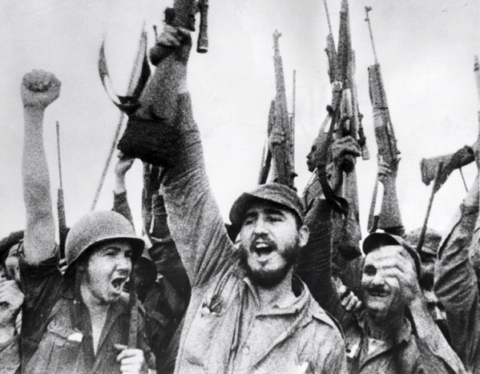
▪ 1st January 1959: Following the fall of Santa Clara, the provincial capital, Batista fled to the Dominican Republic. He left behind a junta headed by General Eulogio Cantillo, who attempted to appoint Dr. Carlos Piedra, the oldest judge of the Supreme Court, as provisional President of Cuba. However, the Supreme Court refused to administer the oath of office to Cantillo as the rebel forces of Fidel Castro seized power throughout the island.
▪ February 1959: Castro announced the suspension of parliamentary democracy and implemented the Fundamental Law of Republic, turning him into a dictator.

