- Key Words and People:
As you complete the activities in this unit, keep a record of new key people and events.
Key People | Significance
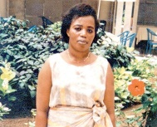  Agathe Uwilingiyimana | Make a link: Kids were saved by Capt Mbaya Diagne who introduced our course
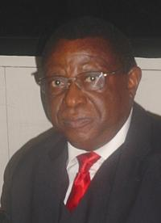
Colonel Bagosora
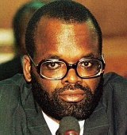
Jean Kambanda

- Sequence of Events: a) The Consolidation of (Hutu) Power
Remember, good ‘History’ is about good understanding of context. When Habyarimana died, the Hutu Extremists were powerful but not ‘in’ power. We have seen that the Head of Intelligence, for example, was half-Tutsi and there were many moderate Hutus who stood in their way. The first priority of the Hutu Power Movement / Zero Network was therefore a directed and swift elimination of these elements while the confusion and panic caused by the assassination gave them a temporary power boost. As well as Hutu moderates, the extremists also (potentially) had to contend with Dallaire and the UNAMIR forces on the ground. Use Reading 1 on the website.
Date | Event | Significance/Elaboration
7th April | The murder of Uwilingiyimana
 | The capture of 10 Belgian peacekeepers | (Motive, consequence)
8th April | Renewal of the Civil War | (RPF responses, Hutu Power thinking?)
8th 9th April | Emergence of Colonel Bagosora
9th April | Appointment of Interim Government | (Kambanda)
Role of RTLM in this period

As you will see, the sporadic massacring of Tutsi’s had already begun, encouraged by the RTLM broadcasts. However, once the Interim Government was firmly in the hands of Hutu Power (along with the re-emergence of the RPF threat which solidified Hutu support behind it) there was a much more decisive role played by the military in organising and coordinating the Interahamwe, the police, their own forces and even the Church.
b) The Key Events of ‘The 100 Days’.
Follow the link to ‘Frontline’. Play the interactive timeline, read the events. Simply copy and paste each event into the table below.
Date | Key Event | Number of Deaths Reached
7th April
9-11 April
15th April
16th April
19th April
21-22nd April
25th April
27th April
28th April
1st May
3rd May
5th May
13th May
17th May
25th May
22nd June
17th July

Highlight in red: Events that indicate international failure to act.
Highlight in blue: Evidence that indicates that the genocide was planned rather than spontaneous.
Highlight in green: Evidence that Dallaire tried to prevent the genocide.
c) Witnesses to Genocide
Watch video 1, 2, 3, 5 (Fergal), 7 (Last US) [use Internet Explorer] They are all voices from witnesses of the genocide – try to take a different one each. If there is time, share. Make some notes in the frame below – see if they shed any light on the guiding questions (you may wish to add your own in at this point too).
Motivation of murderers, role of community leaders, clergy, evidence of moderate Hutus, reactions of victims, RPF, role of army vs Interahamwe etc

d) Case Study of ‘Known’ Incidents
Split into pairs and focus on one of the main incidents of the genocide. Download one of the case studies on the website and interrogate the sources to add to your understanding of the general sweep of events that we have already examined.
Events at Nyaraubuye, 14-15th April 1994

The Ntarama Massacre, 15-16th April 1994

