What were the key events for Hong Kong during the period of the Holocaust?
- SEQUENCING THE KEY EVENTS
Read this timeline – your job is to copy and paste the appropriate picture from the ‘bank’ below next to the event described.
Date | Event | Image
Pre-1938 | Hong Kong has a population of 1.6 million and is governed by Britain. The majority of the residents are of Chinese descent, with around 10,000 British soldiers/administrators
1938 | Japan invades parts of China. Their army faces off against British soldiers across the Lo Wu bridge that marks the border. Tense!
March 1941 | Fearing Japanese attack, many British and Hong Kong Chinese join a volunteer defence force that begins training to support the British army.
December 1941 | Japan launch a surprise attack on the US navy’s main base at Pearl Harbour, destroying a lot of it – this leaves the Pacific Ocean in Japanese hands.
December 1941 | Japan invades Hong Kong – they quickly capture the reservoirs on Kowloon side and tanks start to roll up Kings Road.
December 1941 | North Point burns during the fighting and the British army and the Hong Kong Defence Force are over-whelmed – they have run out of water and are massively out-gunned.
January 1942 | Remaining British civilians were rounded up and sent to an ‘internment’ camp in Stanley
1942-45 | THE JAPANESE OCCUPATION OF HONG KONG. AT LEAST 10,000 CHINESE HONG KONGERS WERE MURDERED BY JAPANSES SOLDIERS, MANY MORE WERE SENT AS SLAVE WORKERS TO JAPANESE FACTORIES IN CHINA. THE TOTAL POPULATION OF HONG KONG FALS FROM 1.6 MILLION TO ONLY 600,000.

Image bank:
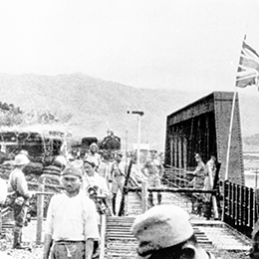 | 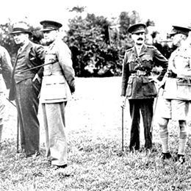 | 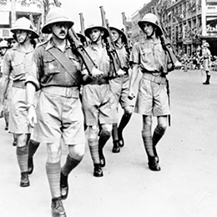
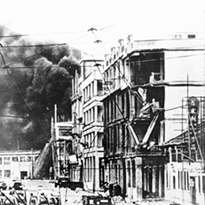 | 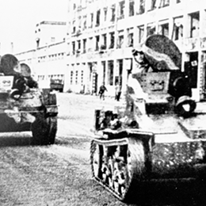 | 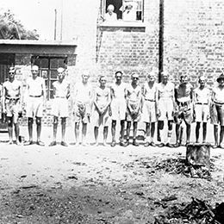
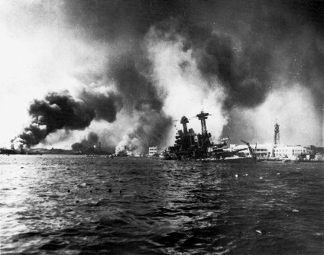

- FINDING OUT WHAT LIFE WAS LIKE FOR ORDNINARY PEOPLE IN HONG KONG? IS THERE ANY CONNECTION WITH THE EXPERIENCE OF JEWS IN NAZI GERMANY?
Using the interviews with the people who experience the Japanese occupation in Hong Kong, complete the table. You are aiming to:
- Identify the key features of life under Japanese occupation
- See if you can identify evidence that there was a process of dehumanisation that took place.

WITNESS  (names/snip an image) | EVIDENCE ABOUT DAILY LIFE  (how life changed/ roles / resistence etc) | EVIDENCE OF DEHUMANISATION

